Chapter 2
C. Dependence on Source to Surface Distance
Photon fluence emitted by a point source of radiation varies inversely as a square of the distance from the source. Although the clinical source (isotopic source or focal spot) for external beam therapy has a finite size, the source to surface distance (SSD )is usually chosen to be large (≥80 cm) so that the source dimensions become unimportant in relation to the variation of photon fluence with distance. In other words, the source can be considered as a point at large source to surface distances. Thus, the exposure rate or “dose rate in free space” (Chapter 8) from such a source varies inversely as the square of the distance. Of course, the inverse square law dependence of dose rate assumes that we are dealing with a primary beam, without scatter. In a given clinical situation, however, collimation or other scattering material in the beam may cause deviation from the inverse square law.
Percent depth dose increases with SSD because of the effects of the inverse square law. Although the actual dose rate at a point decreases with an increase in distance from the source, the percent depth dose, which is a relative dose with respect to a reference point, increases with SSD. This is illustrated in Figure 9.5 in which relative dose rate from a point source of radiation is plotted as a function of distance from the source, following the inverse square law. The plot shows that the drop in dose rate between two points is much greater at smaller distances from the source than at large distances. This means that the percent depth dose, which represents depth dose relative to a reference point, decreases more rapidly near the source than far away from the source.
In clinical radiation therapy, SSD is a very important parameter. Because percent depth dose determines how much dose can be delivered at depth relative to the surface dose or D_{max}, the SSD needs to be as large as possible. However, because dose rate decreases with distance, the SSD, in practice, is set at a distance that provides a compromise between dose rate and percent depth dose.
P.147
For the treatment of deep-seated lesions with megavoltage beams, the minimum recommended SSD is 80 cm.
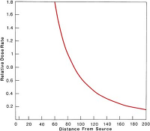 | Figure 9.5. Plot of relative dose rate as inverse square law function of distance from a point source. Reference distance = 80 cm.
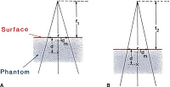 | Figure 9.6. Change of percent depth dose with source to surface distance (SSD). Irradiation condition (A) has SSD = f₁ and condition (B) has SSD = f₂. For both conditions, field size on the phantom surface, r × r, and depth d are the same.
Tables of percent depth dose for clinical use are usually measured at a standard SSD (80 or 100 cm for megavoltage units). In a given clinical situation, however, the SSD set on a patient may be different from the standard SSD. For example, larger SSDs are required for treatment techniques that involve field sizes larger than the ones available at the standard SSDs. Thus, the percent depth doses for a standard SSD must be converted to those applicable to the actual treatment SSD. Although more accurate methods are available (to be discussed later in this chapter), we discuss an approximate method in this section: the Mayneord F factor (20). This method is based on a strict application of the inverse square law, without considering changes in scattering, as the SSD is changed.
Figure 9.6 shows two irradiation conditions, which differ only in regard to SSD. Let P (d,r,f) be the percent depth dose at depth d for SSD = f and a field size r (e.g., a square field of dimensions r × r). Since the variation in dose with depth is governed by three effects—inverse square law, exponential attenuation, and scattering—

where µ is the linear attenuation coefficient for the primary and K_{s} is a function that accounts for the change in scattered dose. Ignoring the change in the value of K_{s} from one SSD to another:

Dividing Equation 9.9 by 9.8, we have:

The terms on the right-hand side of Equation 9.10 are called the Mayneord F factor. Thus:

It can be shown that the F factor is greater than 1 for f₂ > f₁ and less than 1 for f₂ < f₁. Thus, it may be restated that the percent depth dose increases with increase in SSD.

Example 1
The percent depth dose for a 15 × 15 field size, 10-cm depth, and 80-cm SSD is 58.4 (⁶⁰Co beam). Find the percent depth dose for the same field size and depth for a 100-cm SSD.

From Equation 9.11, assuming d_{m} = 0.5 cm for ⁶⁰Co γ rays:

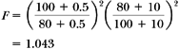
From Equation 9.10:

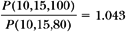
P.148

Thus, the desired percent depth dose is:
P(10,15,100)=P(10,15,80)x1.043
=58.4x1.043=60.9
More accurate methods that take scattering change into account would yield a value close to 60.6.
The Mayneord F factor method works reasonably well for small fields since the scattering is minimal under these conditions. However, the method can give rise to significant errors under extreme conditions such as lower energy, large field, large depth, and large SSD change. For example, the error in dose at a 20-cm depth for a 30 × 30-cm field and 160-cm SSD (⁶⁰Co beam) will be about 3% if the percent depth dose is calculated from the 80-cm SSD tables.
In general, the Mayneord F factor overestimates the increase in percent depth dose with increase in SSD. For example, for large fields and lower-energy radiation where the proportion of scattered radiation is relatively greater, the factor (1 + F)/2 applies more accurately. Factors intermediate between F and (1 + F)/2 have also been used for certain conditions (20).
9.4. Tissue-Air Ratio (TAR)
Tissue-air ratio (TAR) was first introduced by Johns (6) in 1953 and was originally called the “tumor-air ratio.” At that time, this quantity was intended specifically for rotation therapy calculations. In rotation therapy (Figure 9.10), the radiation source moves in a circle around the axis of rotation, which is usually placed in the tumor. Although the SSD may vary depending on the shape of the surface contour, the source-axis distance remains constant.
Since the percent depth dose depends on the SSD, the SSD correction to the percent depth dose will have to be applied to correct for the varying SSD—a procedure that becomes cumbersome to apply routinely in clinical practice. A simpler quantity—namely TAR—has been defined to remove the SSD dependence. Since the time of its introduction, the concept of TAR has been refined to facilitate calculations not only for rotation therapy, but also for stationary isocentric techniques as well as irregular fields.
Tissue-air ratio may be defined as the ratio of the dose (D_{d}) at a given point in the phantom to the dose in free space (D_{fs}) at the same point. This is illustrated in Figure 9.7. For a given quality beam, TAR depends on depth d and field size r_{d} at that depth:
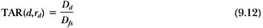
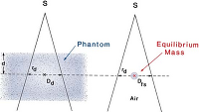 | Figure 9.7. Illustration of the definition of tissue-air ratio (TAR). TAR(d,r_{d}) = D_{d}/D_{fs}.

A. Effect of Distance
One of the most important properties attributed to TAR is independent of the distance from the source with an accuracy of better than 2% over the range of distances. This useful result can be deduced as follows.

Because TAR is the ratio of the two doses (D_{d} and D_{fs}) at the same point, the distance dependence of the photon fluence is removed. Thus, the TAR represents modification of the dose at a point owing only to attenuation and scattering of the beam in the phantom compared with the dose at the same point in the miniphantom (or equilibrium phantom) placed in free air. Since the primary beam is attenuated exponentially with depth, the TAR for the primary beam is only a function of depth, not of SSD. The case of the scatter component, however, is not obvious. Nevertheless, Johns et al. (21) have shown that the fractional scatter contribution to the depth dose is almost independent of the divergence of the beam and depends only on the depth and the field size at that depth. Hence, the tissue-air ratio, which involves both the primary and scatter component of the depth dose, is independent of the source distance.

B. Variation with Energy, Depth, and Field Size
Tissue-air ratio varies with energy, depth, and field size very much like the percent depth dose. For the megavoltage beams, the tissue-air ratio builds up to a maximum at the depth of maximum dose (d_{m}) and then decreases with depth more or less exponentially. For a narrow beam or a 0 × 0 field size³ in which scatter contribution to the dose is neglected, the TAR beyond d_{m} varies approximately exponentially with depth:

where is the average attenuation coefficient of the beam for the given phantom. As the field size is increased, the scattered component of the dose increases and the variation of TAR with depth becomes more complex. However, for high-energy megavoltage beams, for which the scatter is minimal and is directed more or less in the forward direction, the TAR variation with depth can still be approximated by an exponential function, provided an effective attenuation coefficient (µ_{eff}) for the given field size is used.

B.1. Backscatter Factor
The term backscatter factor (BSF) is simply the ratio of the dose on central axis at the depth of maximum dose to the dose at the same point in free space. Mathematically:

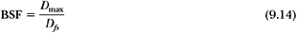
or:

where r_{dm} is the field size at the depth d_{m} of maximum dose.

The backscatter factor, like the tissue-air ratio, is independent of distance from the source and depends only on the beam quality and field size. Figure 9.8 shows backscatter factors for various-quality beams and field areas. Whereas BSF increases with field size, its maximum value occurs for beams having a half-value layer between 0.6 and 0.8 mm Cu, depending on field size. Thus, for the orthovoltage beams with usual filtration, the backscatter factor can be as high as 1.5 for large field sizes. This amounts to a 50% increase in dose near the surface compared with the dose in free space or, in terms of exposure, a 50% increase in exposure on the skin compared with the exposure in air.
For megavoltage beams (⁶⁰Co and higher energies), the backscatter factor is much smaller. For example, BSF for a 10 × 10-cm field for ⁶⁰Co is 1.036. This means that the D_{max} will be 3.6% higher than the dose in free space. This increase in dose is the result of radiation scatter reaching the point of D_{max} from the overlying and underlying tissues. As the beam energy is increased, the scatter is further reduced and so is the backscatter factor. Above about 8 MV, the scatter at the depth of D_{max} becomes negligibly small and the backscatter factor approaches its minimum value of unity.
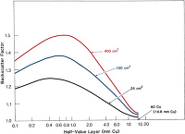 | Figure 9.8. Variation of backscatter factors with beam quality (half-value layer). Data are for circular fields. (Data from Hospital Physicists' Association. Central axis depth dose data for use in radiotherapy. Br J Radiol. 1978;[suppl 11]; and Johns HE, Hunt JW, Fedoruk SO. Surface back-scatter in the 100 kV to 400 kV range. Br J Radiol. 1954;27:443.)

C. Relationship between TAR and Percent Depth Dose
Tissue-air ratio and percent depth dose are interrelated. The relationship can be derived as follows: Considering Figure 9.9A.
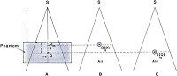 | Figure 9.9. Relationship between tissue-air ratio and percent depth dose. (See text.)

Let TAR(d,r_{d}) be the tissue-air ratio at point Q for a field size r_{d} at depth d. Let r be the field size at the surface, f be the SSD, and d_{m} be the reference depth of maximum dose at point P. Let D_{fs} (P) and D_{fs} (Q) be the doses in free space at points P and Q, respectively (Fig. 9.9B,C). D_{fs} (P) and D_{fs} (Q) are related by inverse square law:

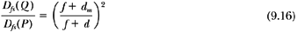

The field sizes r and r_{d} are related by:

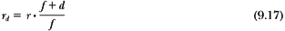

By definition of TAR:
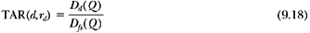

or:
Since:
and, by definition, the percent depth dose P(d,r,f) is given by:
we have, from Equations 9.19, 9.20, and 9.21:
From Equations 9.16 and 9.22:

C.1. Conversion of Percent Depth Dose from One SSD to Another—the TAR Method

In section 9.3C, we discussed a method of converting percent depth dose from one SSD to another. That method used the Mayneord F factor, which is derived solely from inverse square law considerations. A more accurate method is based on the interrelationship between percent depth dose and TAR. This TAR method can be derived from Equation 9.23 as follows.
Suppose f₁ is the SSD for which the percent depth dose is known and f₂ is the SSD for which the percent depth dose is to be determined. Let r be the field size at the surface and d be the depth, for both cases. Referring to Figure 9.6, let r_{d,f1} and r_{d,f2} be the field sizes projected at depth d in Figure 9.6A and B, respectively:
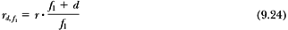
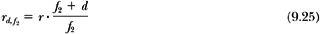
From Equation 9.23:
and:
From Equations 9.26 and 9.27, the conversion factor is given by:
The last term in the brackets is the Mayneord factor. Thus, the TAR method corrects the Mayneord F factor by the ratio of TARs for the fields projected at depth for the two SSDs. Burns (22) has developed the following equation to convert percent depth dose from one SSD to another:

where F is the Mayneord F factor.

Equation 9.29 is based on the concept that TARs are independent of the source distance. Burns' equation may be used in a situation where TARs are not available but instead a percent depth dose table is available at a standard SSD along with the backscatter factors for various field sizes.
As mentioned earlier, for high-energy x-rays, that is, above 8 MV, the variation of percent depth dose with field size is small and the backscatter is negligible. Equations 9.28 and 9.29 then simplify to a use of Mayneord F factor.

Practical Examples
In this section, I will present examples of typical treatment calculations using the concepts of percent depth dose, backscatter factor, and tissue-air ratio. Although a more general system of dosimetric calculations will be presented in the next chapter, these examples are presented here to illustrate the concepts presented thus far.

Example 2
A patient is to be treated with an orthovoltage beam having a half-value layer of 3 mm Cu. Supposing that the machine is calibrated in terms of exposure rate in air, find the time required to deliver 200 cGy (rad) at 5 cm depth, given the following data: exposure rate = 100 R/min at 50 cm, field size = 8 × 8 cm, SSD = 50 cm, percent depth dose = 64.8, backscatter factor = 1.20, and rad/R = 0.95 (check these data in reference 5).
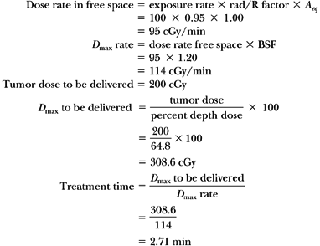
Example 3
A patient is to be treated with ⁶⁰Co radiation. Supposing that the machine is calibrated in air in terms of dose rate free space, find the treatment time to deliver 200 cGy (rad) at a depth of 8 cm, given the following data: dose rate free space = 150 cGy/min at 80.5 cm for a field size of 10 × 10 cm, SSD = 80 cm, percent depth dose = 64.1, and backscatter factor = 1.036.
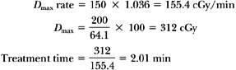
Example 4
Determine the time required to deliver 200 cGy (rad) with a ⁶⁰Co γ-ray beam at the isocenter (a point of intersection of the collimator axis and the gantry axis of rotation), which is placed at a 10-cm depth in a patient, given the following data: SAD = 80 cm, field size = 6 × 12 cm (at the isocenter), dose rate free space at the SAD for this field = 120 cGy/min, and TAR = 0.681.
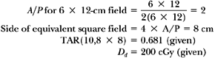
Since TAR = D_{d}/D_{fs}:
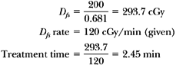
P.153

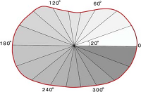  View Figure | Figure 9.10. Contour of patient with radii drawn from the isocenter of rotation at 20-degree intervals. Length of each radius represents a depth for which tissue-air ratio is determined for the field size at the isocenter. (See Table 9.3.)
D. Calculation of Dose in Rotation Therapy
The concept of tissue-air ratios is most useful for calculations involving isocentric techniques of irradiation. Rotation or arc therapy is a type of isocentric irradiation in which the source moves continuously around the axis of rotation.
The calculation of depth dose in rotation therapy involves the determination of average TAR at the isocenter. The contour of the patient is drawn in a plane containing the axis of rotation. The isocenter is then placed within the contour (usually in the middle of the tumor or a few centimeters beyond it) and radii are drawn from this point at selected angular intervals (e.g., 20 degrees) (Fig. 9.10). Each radius represents a depth for which TAR can be obtained from the TAR table, for the given beam energy and field size defined at the isocenter. The TARs are then summed and averaged to determine, as illustrated in Table 9.3.

Example 5
For the data given in Table 9.3, determine the treatment time to deliver 200 cGy (rad) at the center of rotation, given the following data: dose rate free space for 6 × 6-cm field at the SAD is 86.5 cGy/min.
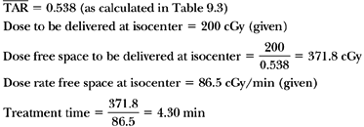

Table 9.3 Determination of Average TAR at the Center of Rotationa
Angle | Depth along Radius | TAR | Angle | Depth along Radius | TAR
0 | 16.6 | 0.444 | 180 | 16.2 | 0.450
20 | 16.0 | 0.456 | 200 | 16.2 | 0.450
40 | 14.6 | 0.499 | 220 | 14.6 | 0.499
60 | 11.0 | 0.614 | 240 | 12.4 | 0.563
80 | 9.0 | 0.691 | 260 | 11.2 | 0.606
100 | 9.4 | 0.681 | 280 | 11.0 | 0.614
120 | 11.4 | 0.597 | 300 | 12.0 | 0.580
140 | 14.0 | 0.515 | 320 | 14.2 | 0.507
160 | 15.6 | 0.470 | 340 | 16.0 | 0.456
ª ⁶⁰Co beam, field size at the isocenter = 6 × 6 cm. Average tissue-air ratio ( = 9.692/18 = 0.538.

9.5. Scatter-Air Ratio
Scatter-air ratios are used for the purpose of calculating scattered dose in the medium. The computation of the primary and the scattered dose separately is particularly useful in the dosimetry of irregular fields.
Scatter-air ratio may be defined as the ratio of the scattered dose at a given point in the phantom to the dose in free space at the same point. The scatter-air ratio, like the tissue-air ratio, is independent of the source to surface distance but depends on the beam energy, depth, and field size.
Because the scattered dose at a point in the phantom is equal to the total dose minus the primary dose at that point, scatter-air ratio is mathematically given by the difference between the TAR for the given field and the TAR for the 0 × 0 field:

Here TAR(d,0) represents the primary component of the beam.
Because scatter-air ratios (SARs) are primarily used in calculating scatter in a field of any shape, SARs are tabulated as functions of depth and radius of a circular field at that depth. Also, because SAR data are derived from TAR data for rectangular or square fields, radii of equivalent circles may be obtained from the table in reference 5 or by Equation 9.7.

