Congestion-aware route selection algorithms for mobile ad hoc networks
Muhsen al-Khalidy and Ismail Ababneh
Computer Science Department, The Hashemite University Zarqa, Jordan
Computer Science Department, Al al_Bayt University, Mafraq, Jordan

Abstract- many existing routing algorithms for ad hoc networks are shortest path algorithms. They select a route with the least number of hops between a communication source and destination. Such routes can, however, include congested nodes. This is especially true for nodes that are located on numerous active communication paths. In this paper, we propose that sources select routes that has the least congested nodes on the route. based on the number of active routes that pass through nodes. Using simulation, we evaluate this approach and compare it to route selection used in Dynamic Source Routing (DSR). The simulation results show that the proposed approach can result in substantial improvement in the delivery ratio and control overhead.
Keywords: Mobile ad hoc networks, on-demand routing, reactive routing, shortest-path routing, congestion-aware routing, congestion-adaptive routing, delivery ratio, control overhead, end-to-end delay, DSR.

Introduction
A mobile ad hoc network (MANET) is a collection of mobile wireless devices that cooperate in forwarding data packets to their destinations. A MANET has no communication infrastructure, therefore its nodes participate in forming routes between sources and destinations, and in forwarding packets until they reach their destinations. Packet forwarding is needed when the sender and receiver are not within the transmission range of each other.
Many routing algorithms proposed for MANETs use the least number of hops as metric for route selection [Abolhasan et al., 2004]. Shortest path routing is, for example, employed in AODV [Belding-Royer and Perkins, 2003], DSR [Johnson et al., 2001], LAR [Ko and Vaidya, 1998], OLSR [Jacquet et al., 2001], and DSDV [Perkins and Bhagwat, 1994]. A problem with this selection scheme is that a node may be located on numerous active communication paths, which can lead to heavy congestion, including hotspots [Lee and Campbell, 2003]. This is especially true of nodes that happen to be often located within the central part of the area covered by the ad hoc network during route discovery operations. Congestion has several disadvantages. It increases the number of dropped packets, control overhead, and end-to-end transfer delays.
Policies that have the destination make the route selection decision were proposed. In these policies, a destination waits for a specific period of time so as to possibly receive the same route request via multiple routes. It then selects a source-destination route based on congestion [Zhou and Hassanein, 2001] [Lee and Gerla, 2001]. Such approach can delay informing the source of the route that it should use for sending packets to the destination. Moreover, the selection may not be based on a sufficient number of routes if the destination’s route-selection waiting period is short. An advantage of having a short waiting period is reducing route discovery delays.
In this paper, we propose that route selection be carried out by the source. A destination immediately informs the source of a route request of all possible source-destination routes as they are discovered. The source can begin packet transmission as soon as it receives the first route, and it can adjust its selection later as it receives additional routes. Routes are selected based on the number of routes that go through their nodes. It is expected that nodes located on fewer routes have lighter traffic and lower congestion. Two route selection schemes are proposed. In the first scheme, the route with the smallest average congestion level computed for its intermediate nodes between the source and destination is selected. In the second scheme, the route with the smallest maximum node congestion value is selected; again, only intermediate nodes are considered because the source and destination are a must. Using simulation, we evaluated the proposed route selection schemes and compared them to route selection used in Dynamic Source Routing (DSR) [Johnson et al., 2001]. In addition, a scheme that selects routes based on the number of available buffers in intermediate nodes was considered. The simulation results show that route selection based on the number of routes that go through nodes can result in substantial improvement in the delivery ratio and control overhead.

Ad Hoc Routing Protocols
Routing protocols for ad hoc networks can be classified into three categories, as follows:
  - Proactive Protocols
These protocols periodically exchange routing information so as to keep an up-to-date view of the network topology [Perkins and Bhagwat, 1994]. This exchange consumes battery power, which can lead to rapid node energy depletion. Moreover, the control overhead associated with these periodic updates can be very high and consume a large fraction of the communication bandwidth. However, routes are known in advance, packet forwarding is immediate, and the delay time of route discovery is very small. The various reactive protocols, such as DSDV [Perkins and Bhagwat, 1994] and WRP [Murthy and Gracia-Luna-Aceves, 1995], are similar in the periodic exchange of network topology information, but they differ in the number of routing tables used and in the method by which they broadcast these tables [Royer and Toh, 1999].
  - Reactive Protocols
Reactive protocols do not exchange periodic information about the network topology. A source node initiates route discovery only when it wishes to send data to a destination to which it knows of no routes, therefore reactive protocols are often called source-initiated or on-demand protocols. In addition to route discovery, reactive protocols have a route maintenance mechanism. This mechanism consists of the set of actions that the protocol carries out for handling route failures when a node discovers a breakdown in an active route. Reactive routing suffers from the delay time that is needed for route discovery. In addition, when the mobility of nodes is high routes are prone to breaks, which can cause much overhead. Typically, sources are notified of breaks and new routes are sought. It is even possible that a fresh route fails before being used. However, reactive protocols are particularly appropriate when node mobility is moderate. Under such conditions, routes are relatively stable and the route discovery and maintenance overhead is small, saving bandwidth for use in sending data packets. Many reactive protocols have been proposed in the literature, including DSR [Johnson et al., 2001], AODV [Belding-Royer and Perkins, 2003], LMR [Corson and Ephremides, 1995], LAR [Ko and Vaidya, 1998] and TORA [Park and Corson, 1997].
Dynamic Source Routing (DSR) Protocol
Dynamic Source Routing (DSR) is a well-known on-demand routing protocol. An advantage of DSR over other reactive protocols is that it stores multiple routes in node caches. This can reduce route discovery operations because a cached route can be used when an active route breaks. Also, DSR does not have periodic Hello messages, which also saves network bandwidth.
When a node wishes to send data packets to a destination, it searches in its cache for a route to the destination. If there are multiple routes, it chooses the least hop count route, but if no route is found, the source node initiates the route discovery process.
For route discovery, a source node transmits a route request as a local broadcast packet. The request is received by all nodes that are neighbors of the source (i.e., the nodes that are within the transmission range of the source node). Each route request is identified by the source node ID, destination node ID, and a unique route request ID. The header of route requests contains a list of addresses of the intermediate nodes through which the request has been forwarded so far. When an intermediate node receives a route request for the first time, it responds to the source with a route if it knows of one to the destination, otherwise it appends its address to the list of route addresses and re-broadcasts the request. If the intermediate node has received the route request previously, it discards it. When a route request reaches the intended destination, the destination replies with a route reply message containing the accumulated route included in the route request received. DSR uses source routing. That is, when a node sends a data packet, its header will contain the set of nodes through which the packet is to travel.
  - Hybrid Protocols
Hybrid protocols combine the reactive and proactive techniques. Typically, the network is divided into several routing areas or zones, a proactive routing protocol is used within the zones, and the protocol that operates between zones is reactive [Abolhasan et al., 2004].

Previous Congestion Research
Congestion in mobile ad hoc networks has recently become an important area of research. When a data packet encounters a congested area, it may be dropped, which causes additional network bandwidth to be consumed when the packet is transmitted again. Additionally, the packets that pass through a congested area suffer long time delays. Trying to develop routing protocols that take into account the congestion status of intermediate nodes is beneficial in avoiding these problems. Congestion-based routing can be classified into two categories. Congestion-aware routing considers congestion when routes are established, whereas congestion-adaptive routing forwards packets via paths that can vary depending on the current known congestion state.
3.1 CADV Routing Protocol
Congestion in DSDV and AODV was investigated in [Lu et al., 2003]. It is a major reason for packet dropping in both protocols. As a result, a congestion-adaptive distance vector routing protocol (CADV) was proposed. The protocol is based on the idea of integrating congestion avoidance mechanisms within proactive routing protocols so as to improve routing performance. In CADV, a node maintains a set of routing entries, where each entry contains an expected delay value that represents the congestion level at a next hop. The value of an expected delay is based on the mean value of delays of the packets sent during a specified period of time. When a node forwards a packet, the routing decision is based on the distance to the destination in addition to the expected delay at the next hop. The protocol tries to balance traffic and avoid congestion by giving priority to a route having low expected delay. For example, if nodes A and B both advertise a route to the destination and if the expected delay at node A is significantly less than that at node B, then A will be chosen as next hop, provided B is not A’s next hop.
3.2 Localized Congestion Control
In [Hogan et al., 2004], it was suggested that congestion be dealt with locally. The routing protocol should alter routes before congestion happens so as to reduce the number of dropped packets. A node periodically monitors its buffers, and if the average queue size exceeds a threshold value the node broadcasts a notification message to all its neighbors, informing them that congestion is about to happen. Nodes record the volume of data that they are forwarding to neighbors. If the level of data volume for any individual neighbor exceeds a prefixed threshold, then the node saves in its tables that the level for this neighbor has exceeded the threshold, but no further action is taken at this time. In the future, if such neighbor informs the node of eminent congestion, the node attempts to find an alternate route to forward the data packets through. This congestion control mechanism was added to DSR. Simulations were carried out to compare the new packet delivery ratio with that of DSR. In almost all simulations, improvements in the percentage of packets delivered can be observed [Hogan et al., 2004].
3.3 Congestion-adaptive Routing Protocol (CRP)
This protocol takes into account the congestion status of the next node when routing data packets. A node has two routes: primary and bypass. When a source node discovers a route to a destination node for the first time, the first path formed becomes the primary route, and all nodes located on a primary route are called primary nodes. A bypass route is one that connects a node on a primary route with another primary node on the same route. It is used in avoiding congestion. While forwarding data packets, a node warns its predecessor when it is about to become congested, so the previous node can use a bypass route to forward a fraction of data packets in order to reduce congestion. A simple method is used in determining the congestion level at a node. A node periodically checks its buffer size, and computes its congestion level as the ratio of the numbers of packets currently buffered to the node buffer size. The mechanism used for splitting traffic among the primary and bypass routes depends on the congestion levels of the next primary node and the bypass route [Tran and Raghavendra, 2006).
3.4 Dynamic Load Aware Routing Protocol (DLAR)
In DLAR, the load of intermediate nodes is measured as the number of packets currently buffered in the interface queue. When a source node wishes to send data to some destination for which it has no known route, it initiates a route request operation. Intermediate nodes piggyback their load values with the route request and broadcast it. When the destination node receives a route request packet, it waits for some period of time for the sake of receiving other route requests forwarded via different routes. Then, the destination selects the best route with respect to the load value and sends a route reply back to the source using the selected route. In this protocol, intermediate nodes are prohibited from initiating route replies even if they have routing information. This is so that the destination node can select the proper route according to the load levels of intermediate nodes. During the transmission of data packets, intermediate nodes periodically piggyback their load values with the data packets. Destination nodes monitor this information and can select new routes before congestion happens. They inform sources of new better routes using unsolicited route replies [Lee and Gerla, 2001].
3.5 Load-Balanced Wireless Ad Hoc Routing
In this scheme, route discovery is also congestion-aware and has the destination make the route selection decision. A destination waits for a specific route-select period of time so as to possibly receive the same route request via multiple routes. It then selects a source-destination route based on the number of routes that go through its nodes and their neighbors, excluding the source and destination [Zhou and Hassanein, 2001]. An issue with this scheme is that neighboring nodes are not fixed. They typically change because of node movement.
Also, route selection carried out by the destination, as proposed in [Lee and Gerla, 2001] and [Zhou and Hassanein, 2001], can delay informing the source of the route that it should use for sending packets to the destination. Moreover, the selection may not be based on a sufficient number of routes if the destination’s waiting period is short. A reason for having a short waiting period is reducing route discovery delays.
Other route selection metrics have been proposed recently. In [Souihli et al., 2009], it was proposed to use the routing table size as node congestion parameter for reactive routing protocols. The rationale is that this size represents the degree of node centrality, and central nodes suffer form congestion. An issue with this approach is that routing table sizes are algorithm-dependant. For example, DSR stores many more routes than AODV.

Proposed Congestion-aware Route Establishment Algorithm
Most proposed reactive routing algorithms have route discovery mechanisms that choose routes with the smallest number of hops. In this paper, we propose that routes be selected based on the number of active routes that go through their intermediate nodes. This assumes that congestion at a node can be determined by the number of active paths that pass through it. In addition, we consider using the number of packets buffered at a node as node congestion indicator.
Using Figure 1, we illustrate why the shortest path metric may not be the best choice. In the figure, several routes have been established. The first route is from node 1 to node 5. The path is 1-7-4-5. The second route is from node 11 to node 3. The path is 11-8-7-3. The third route is from node 6 to node 2. The path is 6-8-7-2. From this information, we can see that node 8 is located on two routes, while node 7 is located on three routes. The probability of packet dropping by these two nodes is likely to be higher than that of other nodes. The reason is simply that these nodes are likely to receive more packets than the remaining nodes. Suppose that node 10 wants to send data packets to node 5. In the traditional least hop count metric used in most routing protocols, the source node may select the route 10-1-7-4-5. But this route may not be the best with respect to congestion because the intermediate node 7 is located on three routes. The longer route 10-1-2-3-4-5 may be superior because it is less congested.
4.1 Node Congestion Level
In our path-intensity algorithms, every node has a congestion weight associated with it. The weight represents the number of paths that go through the node. In the initial state, all nodes have a congestion value of zero. As a node becomes a part of a new route, its value is incremented by one. The nodes save, in their tables, the number of active routes that they are located on, and they piggyback these values with route replies so that source nodes can select routes based on this information. Nodes use timers to delete unused routes. For instance, if a node does not receive data packets from some upstream node for some timeout period, it decreases its congestion value by one. Thus, the congestion values at nodes are updated. Using simulations, we have considered different values for this timeout period (2 sec, 1.5 sec, 1.25 and 1 sec), and empirically determined that one second is overall the best timeout period.
The congestion level at a node is computed as follows:
- As a node becomes a part of a new route, it increases its congestion value by one.
- A node decreases its congestion value by one if either of the following conditions is met:
- It initiates or forwards a route error from any node to a source node. A node forwards a route error for a downstream node only if it is on the route.
- A path is no longer valid. A node knows that a path is no longer valid when the upstream node does not send a data packet during the timeout period. This means that either a source node has completed transferring data packets to a destination during a session, or the path is no longer valid because of the mobility of an upstream node or this particular node.
Intermediate nodes are prohibited from replying to route requests from their cache memory so as to enable the source node to get fresh information about the congestion status of all nodes that are located on the route towards the destination.
4.2 Route Selection Techniques
Let a route X consist of n intermediate nodes, and let every intermediate node i have a congestion value cong(i) for i = 1, 2, ..., n. In order to select the minimum congested route from multiple available routes, we consider the congestion value of the intermediate nodes. We eliminate the source and destination nodes from consideration in the selection process because they are a must for a given source-destination communication.
The proposed alternatives for selecting the least congested route are as follows:
- The route that has the lowest maximum node congestion value is selected. This is referred to as the LEASTMAX method.
- The route with the minimum average congestion value is selected. This is referred to as the LEASTAVRG method.
4.3 The Buffer Ratio Algorithm
In this route selection algorithm, the congestion level of a node is the ratio of the number of data packets currently stored in the node’s buffer to the total node buffer size. Upon receiving a route reply, an intermediate node piggybacks its buffer size ratio with the route reply. When the source node receives a route reply, it knows the buffer ratios of all intermediate nodes and selects the route with the minimum average buffer ratio. We have called this algorithm BUFFRATIO.

Simulation
We have implemented the proposed route selection schemes in the GloMoSim simulator [Bajaj et al.] so as to evaluate them via comparison with DSR. For node movement, we used the random-waypoint model, where a node randomly chooses a destination in the area where the nodes are located, and moves in the direction of this position with a speed uniformly chosen between a min and a max speeds. When the node reaches its destination, it stations there for a pause-time time period. Then, it selects another destination and moves towards it. Our simulations modeled a network of 50 mobile nodes placed randomly within a 1500 meters × 300 meters area. Each node has a radio propagation range of 250 meters and the channel capacity is 2 Mbps. Each run lasted for 900 seconds of simulation time. The MAC layer protocol used was the IEEE 802.11 protocol. The traffic generator assumed simulates constant bit rate sources. The size of the data payload was 512 bytes. The min and max speeds were set to zero and 20 meters/s, respectively. To broadly evaluate the performance of our algorithms, we used the pause times 0, 300, 600 and 900 seconds for each experiment. Also we varied the transmission rate, using 1, 2, and 4 packets per second, repeated for 5, 10, and 20 sources.
5.1 Performance Parameters
Several parameters have been proposed for evaluating the performance of routing protocols in ad hoc networks. Commonly, the following parameters are used in such evaluation:
Control Overhead: The control overhead is the total number of control packets sent divided by the total number of data packets received. For example, if we send 2000 control packets for 1000 received data packets, then the overhead is 2. This means that for every data packet to be delivered we need two control packets, on average.
Delivery Ratio: The delivery ratio is the ratio between the number of received data packets and the number of data packets sent. For instance, if by the end of a simulation the destinations have successfully received 800 data packets from 1000 data packets that were sent by the network layer, then the delivery ratio is 80%.
Average End-to-End Delay: Is the average delay of all data packets that were sent from sources to destinations.
5.2 Simulation Results
Our proposed algorithms LEASTAVRG and LEASTMAX outperformed DSR in terms of delivery ratio in virtually all cases considered, as can be seen in Figures 2-7. The reason is that these algorithms select routes that are less congested than others, which decreases packet dropping and increases delivery ratio. It can also be observed in the figures that the advantage of LEASTAVRG and LEASTMAX is overall higher when mobility is high (pause-time = 0 s). In Figure 2, for example, LEASTAVRG and LEASTMAX outperform DSR by 18.6 and 20 percent for high mobility, while for low mobility (pause-time = 900 s) they outperform DSR only by 6.31 and 8 percent. The BUFFRATIO algorithm outperforms DSR when node mobility is high in some experiments. For example, BUFFRATIO outperforms DSR for five sources and all transmission rates considered when node mobility is high. Moreover, it outperforms DSR when the number of sources is ten, the transmission rate is one packet per second, and mobility is high. It has poor performance in terms of delivery ratio in the remaining cases. This means that the buffer ratio metric is not as accurate as the two metrics that use the number of active routes through nodes.
Regarding the control overhead, all policies generated relatively few overhead packets, except for high mobility. LEASTAVRG and LEASTMAX outperformed DSR overall when mobility was high. However, their performance advantage decreased with increases in the product of the number of sources by the packet transmission rate, as can be seen in Figures 8, 9 and 10. In Figure 8, for example, LEASTAVRG and LEASTMAX outperform DSR by 45 and 49 for high mobility. For low mobility, LEASTMAX outperforms DSR by 16 percent, while DSR and LEASTAVRG have almost similar performance. The BUFFRATIO algorithm outperformed DSR in some cases of high and medium mobility only when the number of sources was five.
The relative end-to-end delay performance of the proposed algorithms against DSR was variable. This is because DSR uses a shortest available route, which may be congested. But in LEASTAVRG and LEASTMAX packets may travel through a longer, but less-congested route. As a result, the proposed algorithms outperformed DSR in some cases; in others, they did not. In Figure 11, for instance, where the number of sources is five and the transmission rate is one packet per second, LEASTAVRG and LEASTMAX outperform DSR by about 33 and 38 percent under high mobility. However, in the case of low mobility DSR has almost the same performance as LEASTAVRG and LEASTMAX. On the other hand, DSR is overall superior to the remaining policies in Figure 12. Also, the simulation results have shown that the end-to-end delays of BUFFRATIO are overall much worse than those of all other policies.

Conclusions
In this paper, we have proposed that sources select routes based on the path intensities at their nodes, where a node’s path intensity is the number of active routes that pass through the node. The path intensities of intermediate nodes located on source-destination routes are conveyed to sources with route replies from destinations. A source then selects and uses a route that has the smallest path intensity or the smallest average path intensity. Using detailed simulations, we have evaluated this congestion-aware route selection approach and compared it to route selection used in Dynamic Source Routing (DSR). The simulation results show that the proposed approach can result in substantial improvement in the delivery ratio and control overhead.
1

2

3

10

4

7

5

81

1111

611

Figure 1. A group of mobile nodes with several active routes
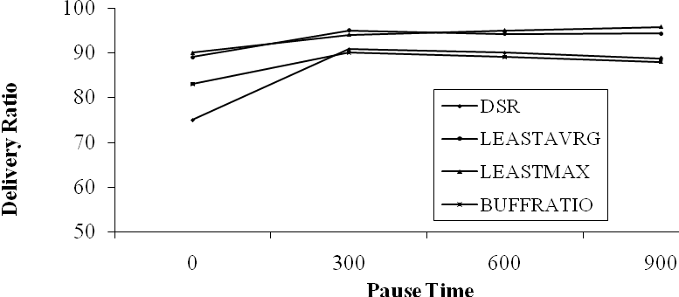
Figure 2. The delivery ratio for 5 sources, each sending 1 packet per second

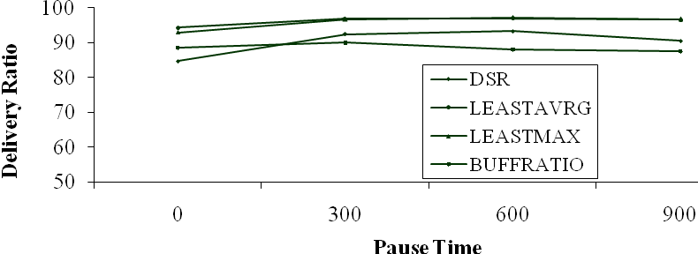
Figure 3. The delivery ratio for 5 sources, each sending 4 packets per second

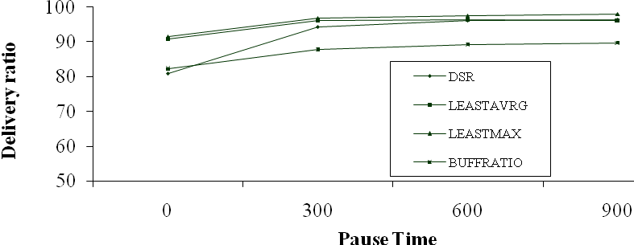
Figure 4. The delivery ratio for 10 sources, each sending 1 packet per second

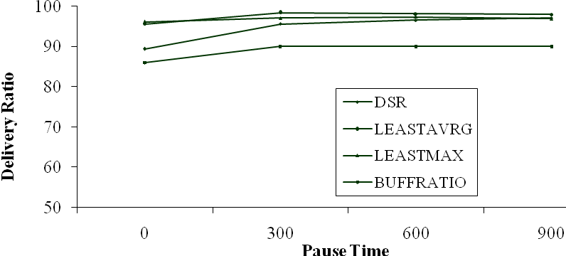
Figure 5. The delivery ratio for 10 sources, each sending 4 packets per second

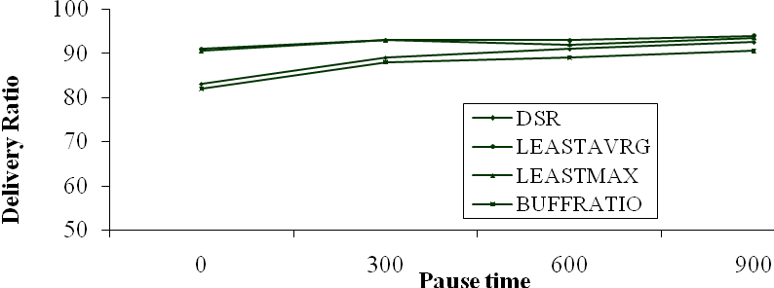
Figure 6. The delivery ratio for 20 sources, each sending 1 packets per second

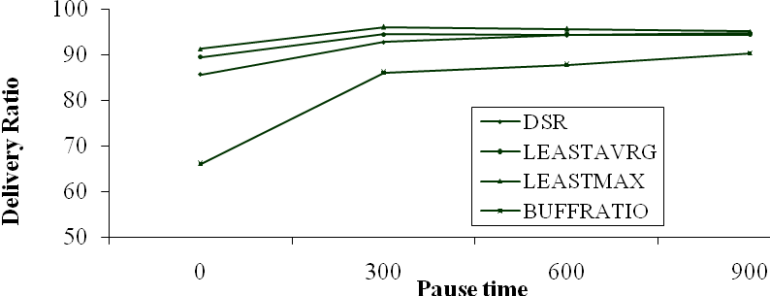
Figure 7. The delivery ratio for 20 sources, each sending 4 packets per second

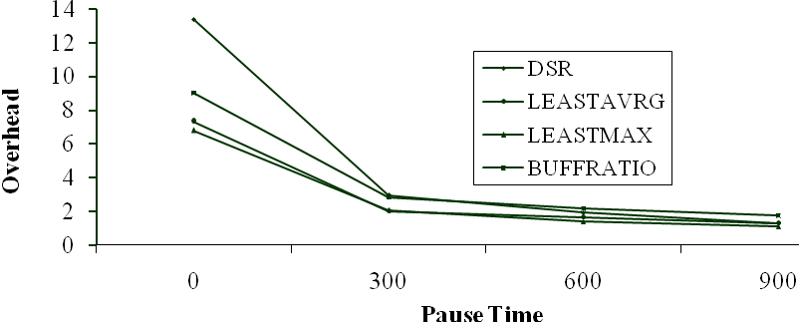
Figure 8. Overhead for 5 sources each sending 1 packet per second

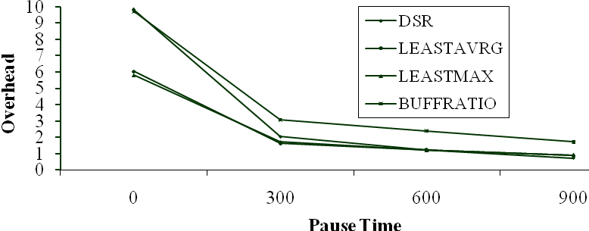
Figure 9. Overhead for 10 sources each sending 1 packet per second

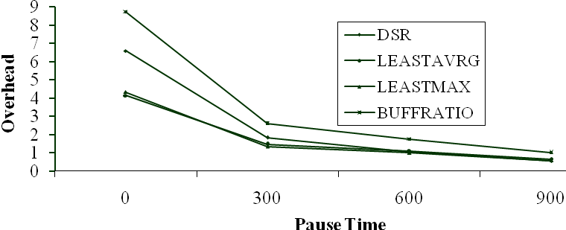
Figure 10. Overhead for 20 sources each sending 1 packet per second

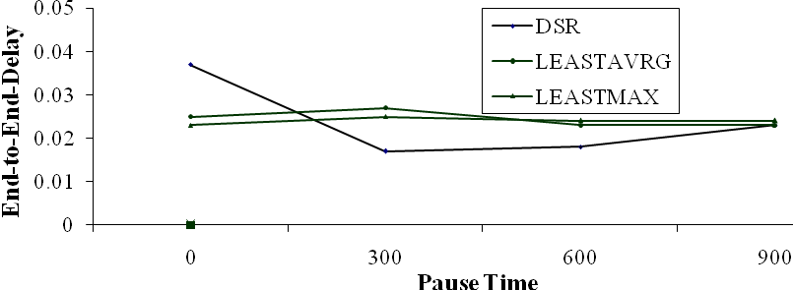
Figure 11. End-to-End-Delay for 5 sources sending 1 packet per second

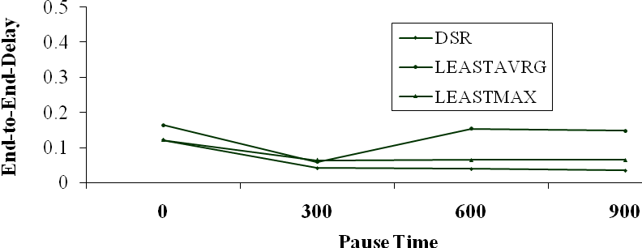
Figure 12. End-to-End-Delay for 20 sources sending 4 packet per second

References
[1] Abolhasan, M., Wysocki, T. and Dutkiewicz, E. (2004) ‘A review of routing protocols for mobile ad hoc networks’, Ad Hoc Networks, Vol. 2, pp. 1-22.
[2] Bajaj, L., Takai, M., Ahuja, R., Tang, K., Bagrodia, R. and Gerla, M. ‘GloMoSim: a scalable network simulation environment’, Technical Report, UCLA Computer Science Department -990027.
[3] Belding-Royer, E. and Perkins, C. (2003) ‘Evolution and future directions of the ad hoc on-demand distance-vector routing protocol’, Ad Hoc Networks, Vol. 1, pp. 125-150.
[4] Corson, M. and Ephremides, A. (1995) ‘A distributed routing algorithm for mobile wireless networks’, ACM/Baltzer Wireless Networks, Vol. 1, No. 1, pp. 61–81.
[5] Jacquet, P., Muhlethaler, P., Clausen, T., Laouiti, A., Qayyum, A. and Viennot, L. (2001) ‘Optimized link state routing protocol for ad hoc networks’, IEEE INMIC, Pakistan.
[6] Johnson, D., Maltz, D. and Broch, J. (2001) ‘DSR: The Dynamic Source Routing Protocol for Multi-Hop Wireless Ad Hoc Networks’, Ad Hoc Networking, edited by Charles E. Perkins, Chapter 5, Addison-Wesley, pp. 139-172.
[7] Hogan, B., Barry, M. and McGrath, S. (2004) ‘Congestion avoidance in source routed ad hoc networks’, in: Proceedings of the 13th IST Mobile and Wireless Communications Summit, Lyon, France, June 27 – 30.
[8] Ko, Y.-B. and Vaidya N.H. (1998) ‘Location-aided routing (LAR) in mobile ad hoc networks’, in: Proceedings of the Fourth Annual ACM/IEEE International Conference on Mobile Computing and Networking (Mobicom_98), Dallas, TX.
[9] Lee, S.-B. and Campbell, A. (2003) ‘HMP: hotspot mitigation protocol for mobile ad hoc networks’, in: Proceedings of the 11th IEEE/IFIP International workshop on quality of service (IWQOS), Monterey, CA, USA.
[10] Lee, S.-J. and Gerla, M. (2001) ‘Dynamic load-aware routing in ad hoc networks’, in: Proceedings of the IEEE International Conference on Communications (ICC), Helsinki, Finland, pp. 3206-3210.
[11] Lu, Y., Wang, W., Zhong, Y. and Bhargava, B. (2003) ‘Study of distance vector routing protocols for mobile ad hoc networks’, in: Proceedings of IEEE International Conference on Pervasive Computing and Communications (PerCom’2003),Texas, USA.
[12] Murthy, S., Garcia-Luna-Aceves, J. (1995) ‘A routing protocol for packet radio networks’, in: Proceedings of the First Annual ACM International Conference on Mobile Computing and Networking, Berkeley, CA, pp. 86–95.
[13] Park, V. and Corson, M. (1997) ‘A highly adaptive distributed routing algorithm for mobile wireless networks’, in: Proceedings of INFOCOM.
[14] Perkins, C. and Bhagwat, P. (1994) ‘Highly dynamic destination-sequenced distance vector routing (DSDV) for mobile computers’, in: Proceedings of the Conference on Communications Architectures, Protocols and Applications (ACM SIGCOMM ’94), London, United Kingdom, pp. 234–244.
[15] Royer, E. and Toh, C.-K. (1999) ‘A Review of current routing protocols for ad hoc mobile wireless networks’, IEEE Personal Communications, Vol. 6, No. 2, pp. 46-55.
[16] Souihli, O., Frikha, M. and Ben Hamouda, M. (2009) ‘Load-balancing in MANET shortest-path routing protocols’, Ad Hoc Networks, Vol. 7, pp. 431-442.
[17] Tran, D. and Raghavendra, H. (2006) ‘Congestion Adaptive Routing in Mobile Ad hoc Networks’, IEEE Trans. Parallel Distrib. Syst., Vol. 17, No. 11, pp. 1294-1305.
[18] Zhou, A. and Hassanein, H. (2001) ‘Load-balanced wireless ad hoc routing’, in: IEEE Canadian Conference on Electrical and Computer Engineering, Vol. 2, pp. 1157–1161.

