Hashemite University/ Queen Rania Institute of Tourism and Heritage
Spring 2007/2008
Seminar Course / First Exam Type B
Name and ID: --------------------------------------------------------

After discussing the main concepts of research in the class, you should be able now to write this open book exam which requires the following:
Look at the following model and try to get a topic in tourism that is based on this model:
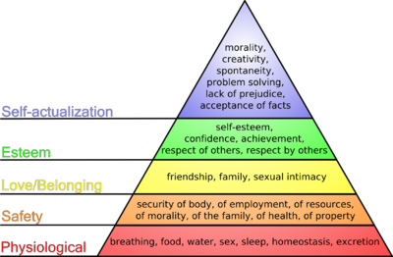

From: http://aaron-ng.info/blog/images/maslow.png
People do things for certain motives. Abraham Maslow with his theory of motivation identifies different stages and forms of motives which will motivate people in different stages of their lives. This theory also presents a relationship between these needs. These needs are presented in a hierarchy. The higher level needs will be activated when the lower level needs are satisfied according to Maslow. The figure below presents the Maslow’s hierarchy of needs. (Quoted from: http://www.leanmanufacturingconcepts.com/Articles/Miscellaneous/AbrahamMaslowTheory.htm)
Now answer the following:

Suggested Topic: -------------------------------------------------------------------------

- After choosing your topic, write a specific research question and identify the problem of your research topic.

- Put a number of hypotheses in regard to the relationship among the constructs of your research.

- Identify your population and sample of interest.

- Identify the variables you are going to deal with.

- Try to suggest a research method to solve the questions of your research.

Good Luck!!!!!

