Faculty of Nat. Res. and Environ-Dept. of Earth and Environ. Sci PRACTICAL STRUCTURAL GEOLOGY (LAB 6)

Lecturer: Dr. Masdouq Al-Taj

THE MOHR DIAGRAM AND MOHR CIRCLE OF STRESS

Stress (δ) is measured in units of force (F) per unit area (A), for which the basic unit is the Pascal (Pa) (1 Pa = 1 Newton per square meter).Also, bar is used by some geologist, 10⁵ Pa = 1 bar, which is approximately equal to atmospheric pressure at sea level. The most convenient unit for most geologic applications is the mega Pascal (MPa), which is equal to 10⁶ Pa or 10 bars. Stress within the earth’s crust ranges up to about 10³ MPa.
Forces are transmitted from one point to another through the earth. These are the forces that produce the faults and the folds. In this lab we will investigate how the magnitude of the principal stresses influences brittle deformation. The chief objective is to be able to determine the differential stress at which a particular brittle failure will occur. It is emphasized that the following discussion applies only to isotropic, homogeneous materials.

THREE PRINCIPAL STRESSES
Imagine a hand pushing diagonally on a table top. The stress acting on the table top can be resolved into two components: normal stress (σ_{n} ) acting perpendicular to the surface and shear stress (σ_{s} ) or some times called (τ) acting parallel to the surface. Although both normal and shear stresses are acting on the table top, we can easily imagine a plane perpendicular to the arm in which the shear stress is zero (Fig. 1).

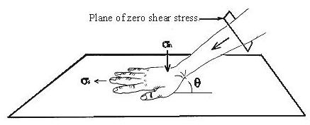

Fig. (1): Normal and shear stresses.
Within a body under stress from all directions there are always three planes of zero shear stress; these are called the principal planes of stress. The three normal stresses that act on these planes are called the principal stresses. The three principal stresses are called σ_{1,} σ₂ and σ₃ in order of magnitude where σ₁≥ σ₂≥ σ₃. Together they define the stress ellipsoid (Fig. 2).

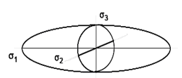

Fig. (2): Stress ellipsoid.

QUANTIFYING TWO DIMENSIONAL STRESS
Experimental rock fracturing has shown that the difference in magnitude between σ₁ and σ_{3,} called the differential stress, is the most important factor in causing rocks to fracture. The magnitude of σ₂ is not believed to play a major role in the initiation of the fracture. For this reason we will examine stress in two dimensions in the σ₁₋ σ₃ plane.
If we know the orientations and magnitudes of σ₁ and σ_{3,} then we can determine the normal and shear stress acting across any plane perpendicular to the σ₁₋ σ₃ plane. Consider the plane in Figure (3a). We want to determine the normal and shear stresses acting on that plane. To simplify the situation we will isolate the plane along with two adjacent surfaces that are perpendicular to σ₁ and σ₃ (Fig. 3b). Viewed in the σ₁₋ σ₃ plane, we will call these surfaces A and B and define the angle θ as the angle between the plane and the σ₃ direction (Fig. 3c). This is equivalent to the angle between σ₁ and the normal to the plane.
If our triangle in Figure (3c) is not moving, then it must be in equilibrium. This means that the normal stress (σ_{n} ) and shear stress (σ_{s} ) acting on the plane must be equal to σ₁ and σ₃ acting on surfaces A and B. We will use this equilibrium relationship to define σ_{n} and σ_{s} in terms of σ₁, σ₃ and θ.
Figure (3d) shows σ_{n} and σ_{s} acting on the plane, and it also shows the horizontal and vertical components of σ_{n} and σ _{s} . The length of the line that represents the plane is A or B
cosθ sinθ
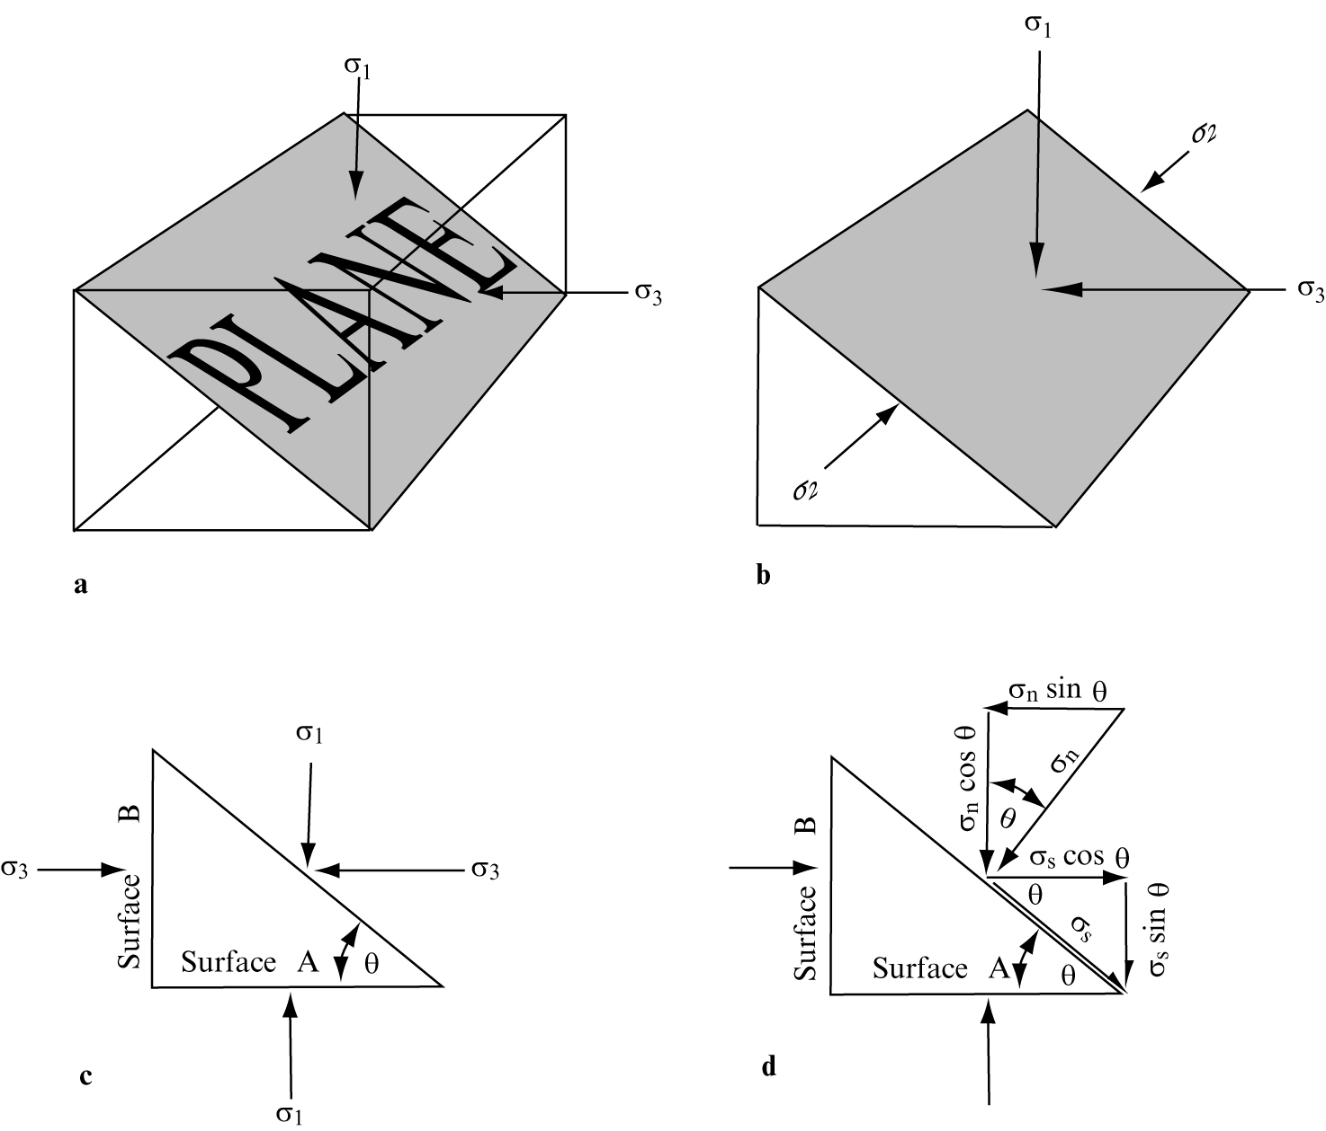
Fig. (3): Two dimensional relationships between a plane and its state of stress. See text for explanation.
The vertical and horizontal forces acting on this line are indicated in Figure (3d). the equations of equilibrium for this plane are as follows:
σ₁ A = A (σ_{n} cos θ + σ_{s} sin θ) (6.1)
cos θ
σ₃ B = B (σ_{n} sin θ - σ_{s} cos θ) (6.2)
sin θ
Solving these equations simultaneously for σ_{n} and σ_{s} in terms of σ₁, σ₃ and θ, we derive the following equations
σ_{n =} σ₁ cos ²θ + σ₃ sin²θ (6.3)
σ_{s} = (σ₁ – σ₃ ) sin θ cos θ (6.4)
in order to reconstitute these equations into a more useful form we can substitute the following trigonometric identities:
sin 2θ = 2sin θ cos θ,
cos ²θ = ½ ( 1 + cos 2θ), and
sin² θ = ½ (1 – cos 2θ).
The result is the following two equations:

σ_{n} = σ₁₊ σ₃ + σ₁ – σ₃ cos 2θ (6.5)
2 2

σ_{s} = σ₁ – σ₃ sin 2θ (6.6)
2

Using equations 6.5 and 6.6, we can determine the normal and shear stresses acting across a plane, if we know the orientations and magnitudes of σ₁ and σ_{3.} Suppose, for example, that in Figure 3. σ₁ = 100 MPa, σ₃ = 20 MPa, and θ = 40°. using equation 6.5 the normal stress is determined as follows:

σ_{n} = σ₁₊ σ₃ + σ₁ – σ₃ cos 2θ
2 2

= (60MPa) + (40MPa) ( 0.17) = 67 MPa
Similarly, equation 6.6 can be used to determine the shear stress acting on the plane:

σ_{s} = σ₁ – σ₃ sin 2θ
2

= (40 MPa) (0. 98) = 39 MPa

Problem 6.1
Given the principle stresses of σ₁ =100 MPa (vertical) and σ₃ = 20 MPa (horizontal), determine the normal and shear stresses on a fault plane that strikes parallels to σ₂ and dips 32°. (Plane 1 in Figure 7a).

THE MOHR DIAGRAM
In 1882 the German engineer Otto Mohr developed a very useful technique for graphing the state of stress of differently oriented planes in the same stress field. The stress (σ_{n} and σ_{s} ) on a plane plot as a single point, with σ_{n} measured on the horizontal axis and σ_{s} on the vertical axis. such a graph is called a Mohr diagram (Figure 4).
Most stresses in the earth are compressive, so geologists, by convention, consider compression to be positive. (In engineering, tension is considered positive). As a practical matter in structural geology, σ_{n} in the earth’s crust is always positive and will therefore always plot on the positive (right) side of the horizontal axis of the Mohr diagram.
The vertical axis of the Mohr diagram, like the horizontal axis, has a positive and negative direction. Shearing stresses that have a sinistral (counterclockwise) sense (Fig. 5a) are, by convention, considered positive and are plotted above the origin. Dextral (clockwise) shearing stresses (Fig. 5b) are plotted on the lower, negative half of the diagram.

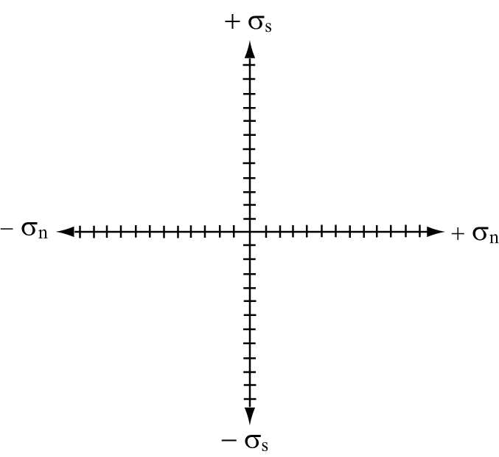

Fig. (4): Mohr diagram for graphing the state of stress of a plane. Within a stress field consisting of a particular combination of σ₁ and σ_{3.} Planes with different dips will experience different magnitudes of σ_{n} and σ_{s} will therefore plot at different points on the Mohr diagram.

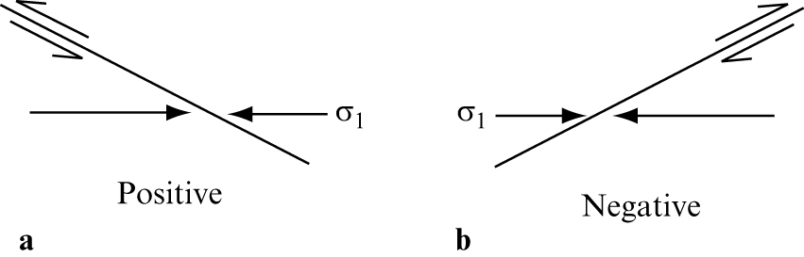

Fig. (5): Conventional signs assigned to shearing stresses for the purpose of plotting on the Mohr diagram. Sinistral shearing (a) is considered positive, dextral shearing (b) is considered negative.

Problem 6.2
Plane 1 in Figure (7) has been plotted on the Mohr diagram in Figure (7b). Determine the σ_{n} and σ_{s} on planes 2 through 5 and plot them on Figure (7b). (Recall that trigonometric functions of angles in the second and fourth quadrants are negative, e.g., cos 180°=-1).

The Mohr circle of stresses

The five points plotted on Figure (7b) (from problem 6.2) should lie on a circle. A key feature of the Mohr diagram is that for a given set of principle stresses the points representing the states of stress on all possible planes perpendicular toe the σ₁ – σ₃ plane graph as a circle. This is called the Mohr circle. As seen in Figure (6), the Mohr circle intersects the σ_{n} axis at values equal to σ₃ and σ_{1.} The radius is (σ₁ – σ₃ )/2 and the center is at (σ₁ + σ₃ ) /2. Note how these expressions relate to equations 6.5 and 6.6.
It is important to understand that the axes of the Mohr diagram have no geographic orientation. They merely allow the magnitudes of stresses on variously oriented planes to be plotted together. Planes perpendicular to either σ₁ or σ₃ (planes 3 and 5 in Figure (7a)) have no shear stress acting on them, so they plot directly on the σ_{n} axis. Shear stress is maximum on planes oriented 45° to the principal stress directions θ=45°). The points representing these planes plot at the top and bottom of the Mohr circle.

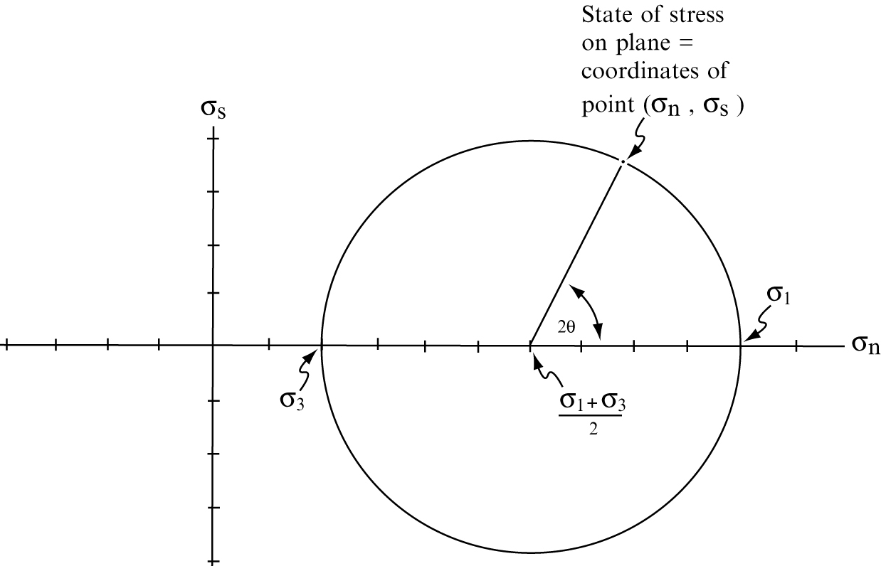

Fig. (6) Main features of Mohr circle of stress. The Mohr circle is the set of states of stress on all possible planes in a two dimensional stress field. The position on the circle of a given plane is determined by finding angle θ (the angle between the plane and σ₃ ) and plotting 2θ on the Mohr circle. Planes with sinistral shear are plotted in the upper hemisphere, planes with dextral shear are plotted in the lower hemisphere, 2θ is always measured (up or down) from the σ₁ intercept.
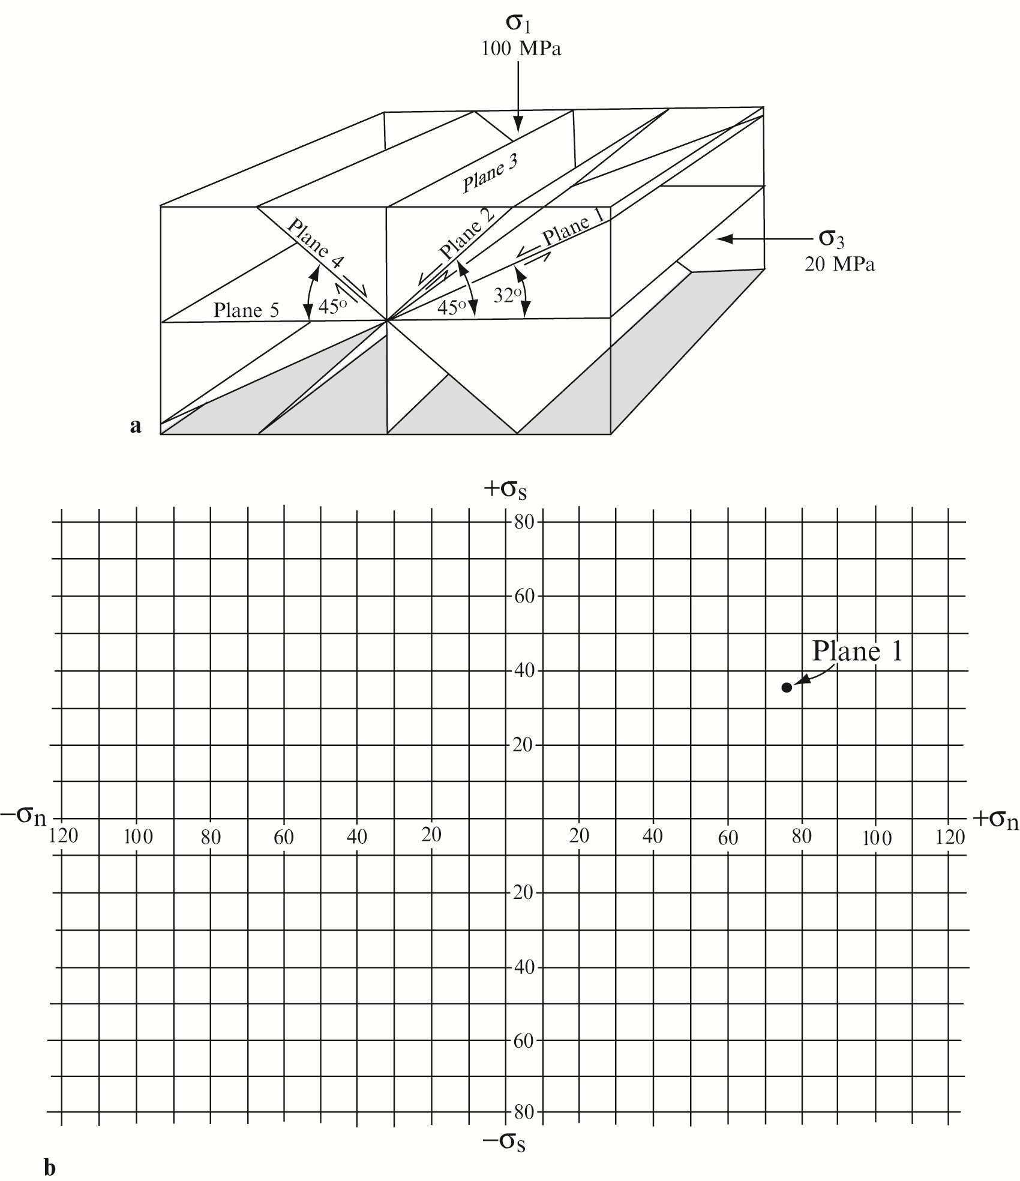
Fig. (7a and b): Five planes within the same stress field (a), for use in problem 6.2. Stresses σ_{n} and σ_{s} acting on plane 1 were calculated in problem 6.1. Mohr diagram for use in problem 6.2 (b).

Values of 2θ can be measured directly off the Mohr circle as shown in figure (6). Angles 2θ corresponding to planes with positive (sinistral) shearing lie in the upper hemisphere of the Mohr circle, while those corresponding to planes with negative (dextral) shearing stresses lie in the lower hemisphere. In either case the angle 2θ is measured from the right hand end of the σ_{n} axis. The chief value of the Mohr circle of stress is that it permits a rapid, graphical determination of stresses on a plane of any desired orientation. Suppose, for example that σ₁ oriented east-west, horizontal, and equal to 40MPa, while σ₃ is vertical and equal to 20MPa. We must find the normal and shear stresses on a fault plane striking north-south and dipping 55ْ west. The solution is as follow:

- Figure (9a) shows the geologic relationships. Before being concerned with the fault plane, construct a Mohr circle of stress for the given values of σ₁ and σ₃ (Figure 9b)
- Next determination the value and sign of angle 2θ for the fault plane. Angle θ is the angle between the fault plane and σ_{3,} which in this case is 35°. So, 2θ is 70°. shearing stresses on this fault have a dextral or negative sense, so angle 2θ is located in the lower hemisphere of the Mohr circle (Figure 9b).
- The normal and shear stress coordinates corresponding the points thus located on the Mohr circle are read directly off the horizontal and vertical axes of the graph. In this example σ_{n} is 33.4MPa and σ_{s} is 9.4 MPa.

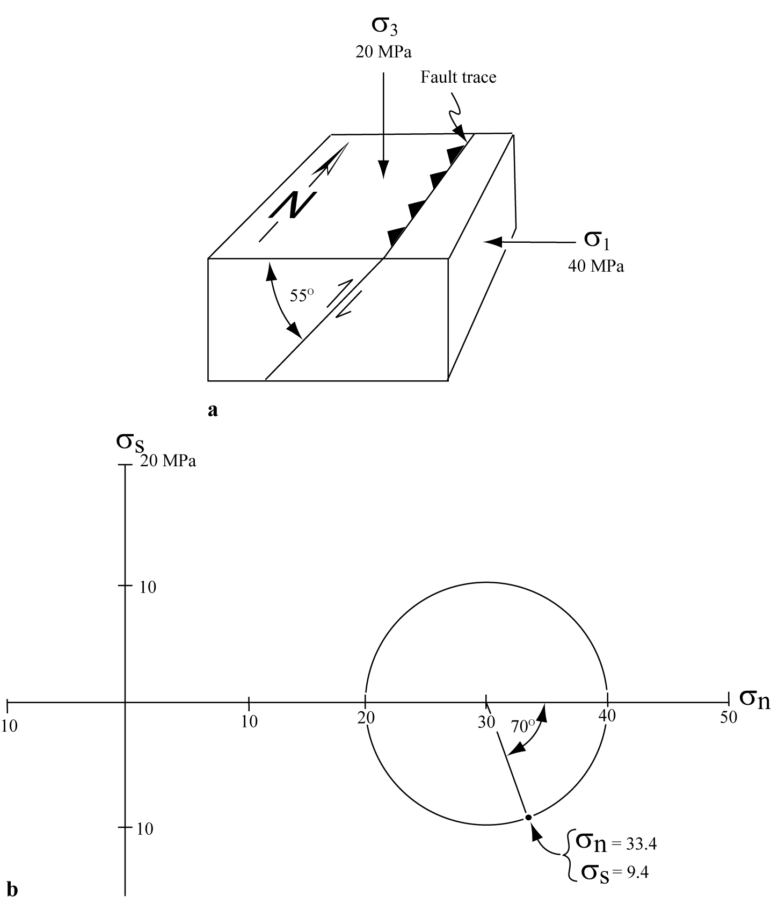

Fig. (9): Mohr circle solution to sample problem requiring determination of σ_{n} and σ_{s} on a particular plane. (a) Block diagram. (b) Mohr circle solution.

Problem 6.3
If σ₁ is vertical and equal to 50MPa and σ₃ is horizontal, east-west, and equal to 22MPa, using a Mohr circle construction determine the normal and shear stresses on a fault striking north-south and dipping 60º east.

