The University of Jordan
Faculty of Science
Department: Geology
Course: Practical Structural Geology
Instructor: Dr. Masdouq Al-Taj

OUTCROP PATTERNS AND STRUCTURE CONTOURS

PART ONE: OUTCROP PATTERNS
OBJECTIVES:
1. To determine the attitude of a plane from its outcrop pattern.
2. Draw a structure contour map.

Because the earth's surface is irregular, planar features such as contacts between beds, dikes, and faults typically form irregular outcrop patterns. Thus, outcrop patterns can serve as clues to the orientations of the planes. Following are seven generalized cases showing the relationships between topography and the outcrop patterns of planes as seen on a map. In Figures (1-7), they cover the block diagram (a) and try to visualize the orientation of the bed from its outcrop pattern in map view (b). Note the symbols that indicate attitudes.
- Inclined planes "V" up-dip as they cross ridges (Fig. 1).
- Horizontal planes appear parallel to contour lines and "V" upstream (Fig. 2).
- Planes that dip upstream "V" upstream (Fig. 4).
- Vertical planes are not deflected at all by valleys and ridges (Fig. 2).
- Planes that dip downstream at a steeper gradient than the stream bed (the usual case) "V" downstream (problem 1).
- Planes that dip downstream at the same gradient as the stream appear parallel to the stream bed (Fig. 5).
- Planes that dip downstream at a gentler gradient than the stream "V" upstream (Fig. 6).
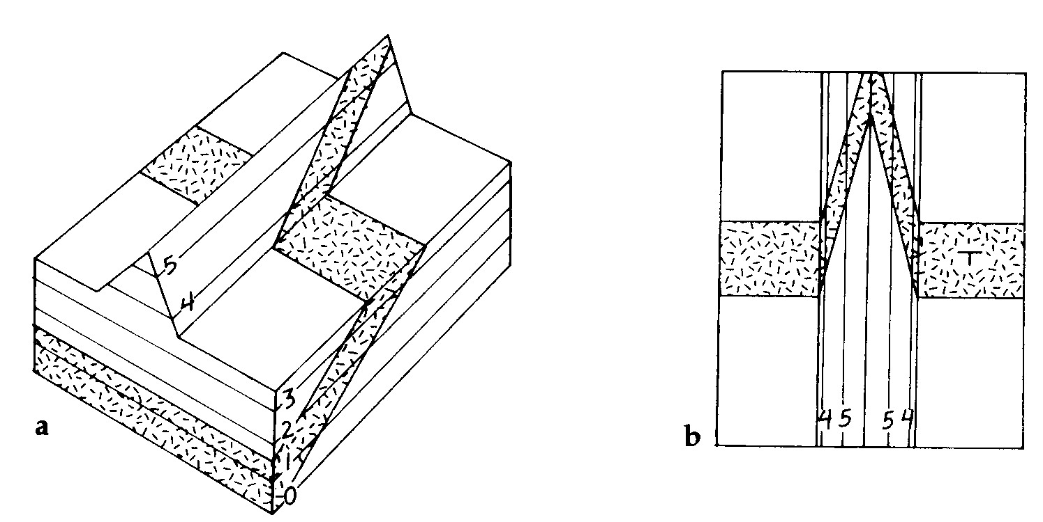

Figure (1) Inclined plane crossing a ridge. (a) Block diagram. (b) Map view
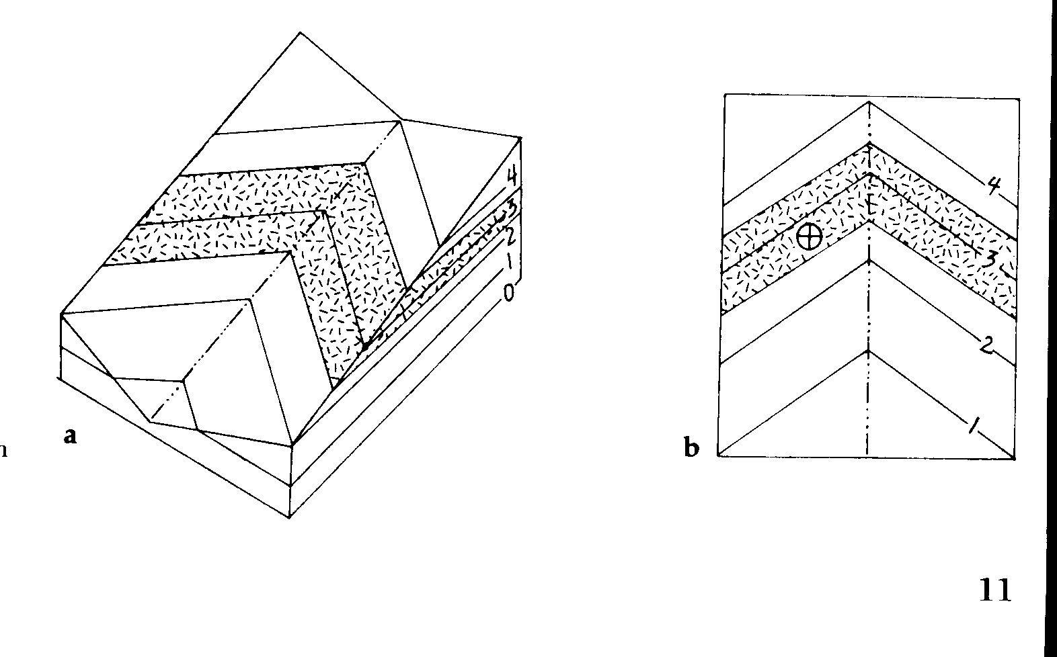

Figure (2) Horizontal plane in a stream valley. (a) Block diagram. (b) Map view

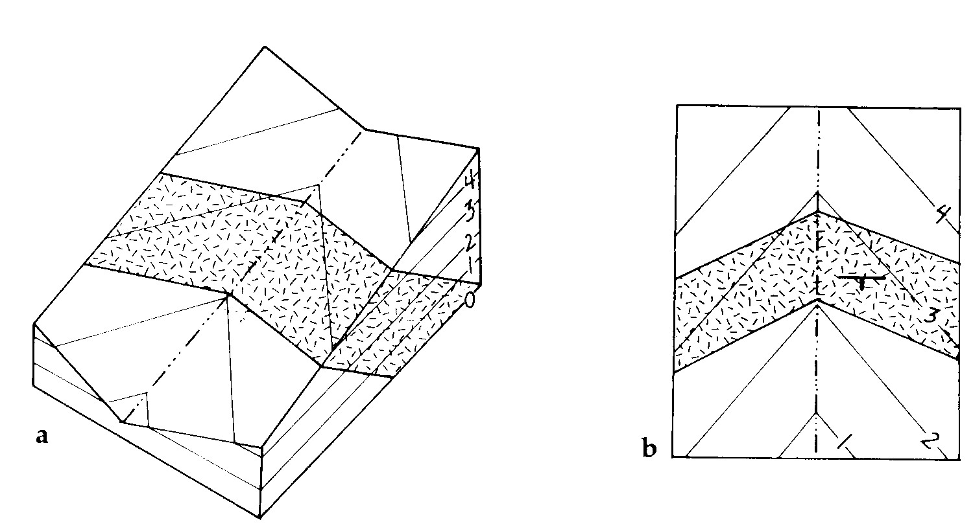

Figure (3) Inclined plane dipping upstream. (a) Block diagram. (b) Map view
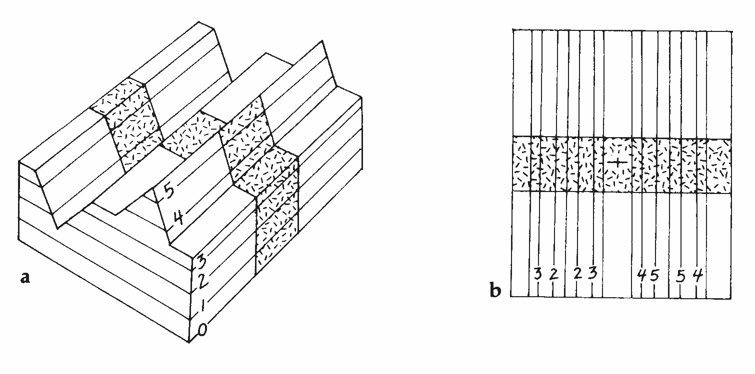

Figure (4) Vertical plane crossing a ridge and valley. (a) Block diagram. (b) Map view

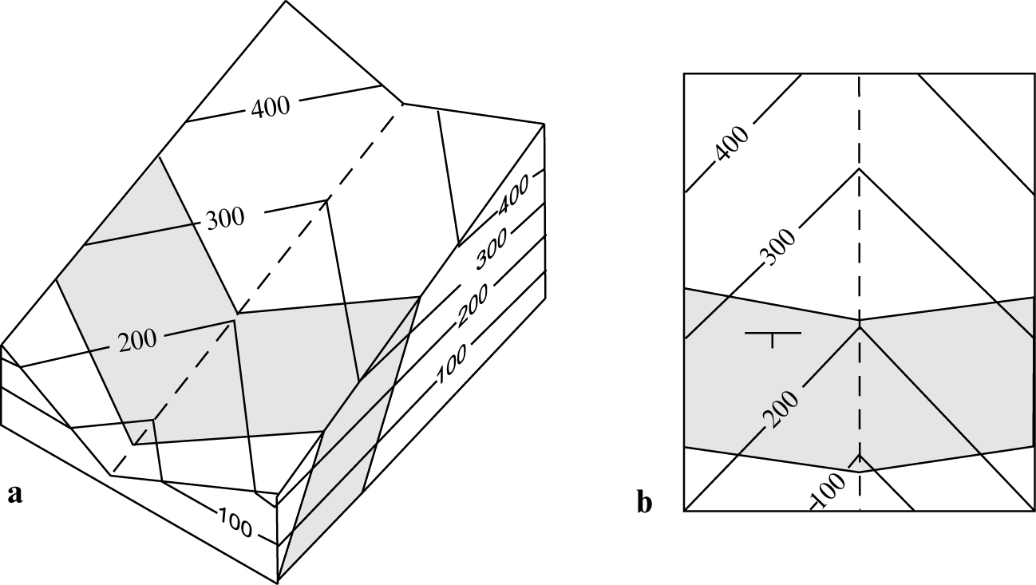
Figure (5) Steeply dipping plane dipping downstream. (a) Block diagram. (b) Map view
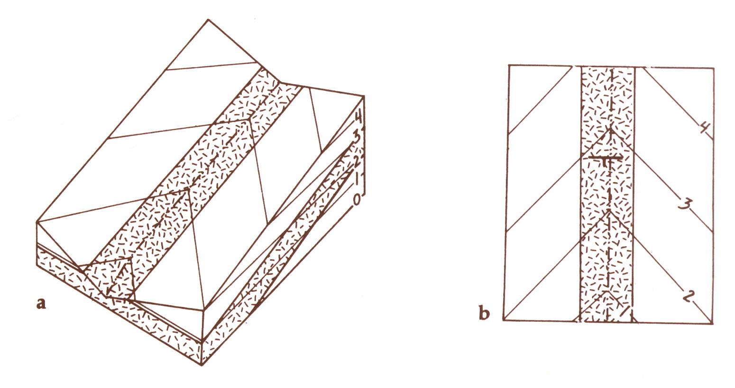

Figure (6) Plane dipping parallel to stream gradient. (a) Block diagram. (b) Map view
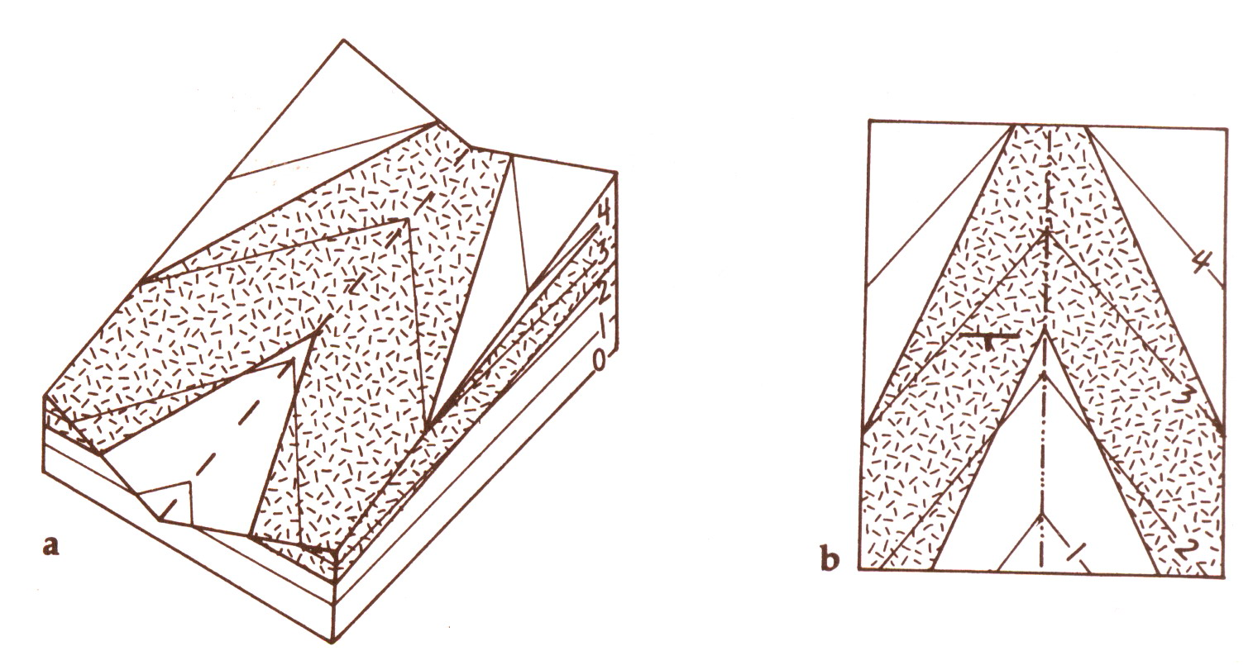

Figure (7) Gently dipping plane downstream. (a) Block diagram. (b) Map view

Problem (1)
On the geological map in Figure (8), draw the correct strike and dip symbol in each circle to indicate the attitude of formation B and each dike. To verify your attitude symbols, Figure (9) can be cut out and folded to form a block model of this map.

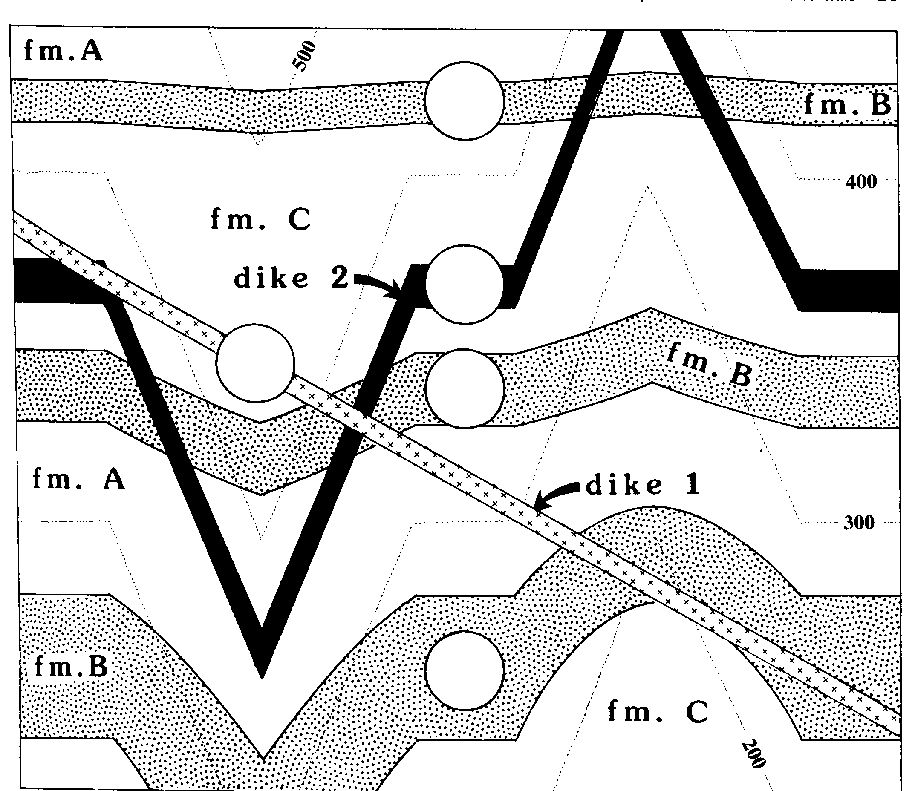

Figure (8) Geologic map for use in Problem (2). Contours are dotted lines. Formation A is the oldest unit. Contour interval is 100 m.

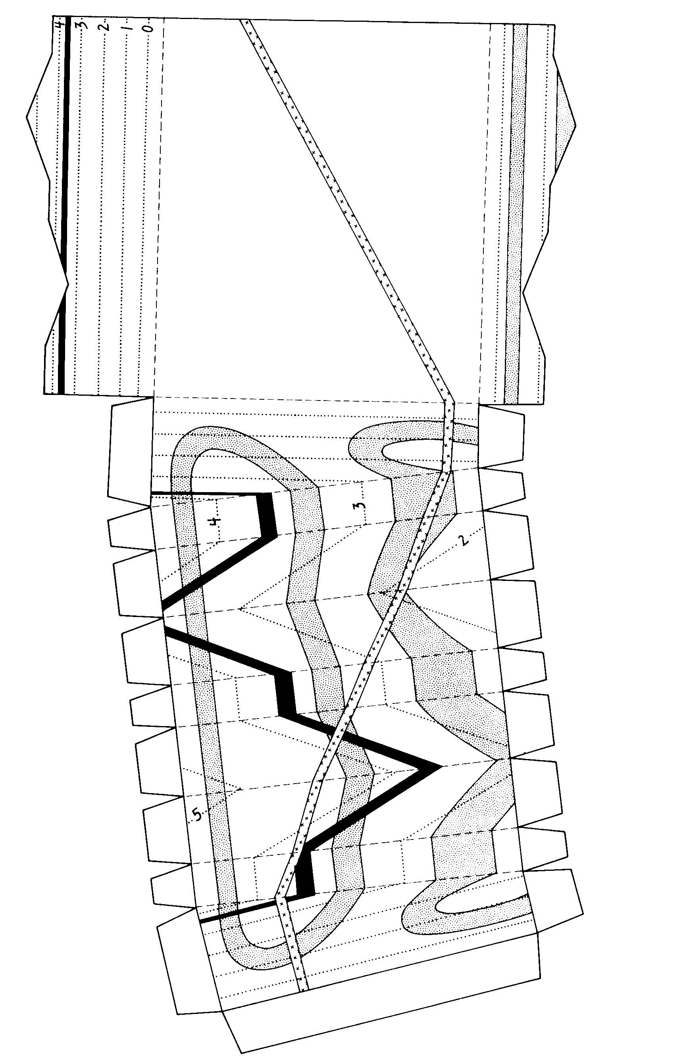

Figure (9) Block model to accompany Problem (1). Cut out the diagram, fold on dashed lines, and glue the tabs.

Q) From the following determine the outcropped layers situations.
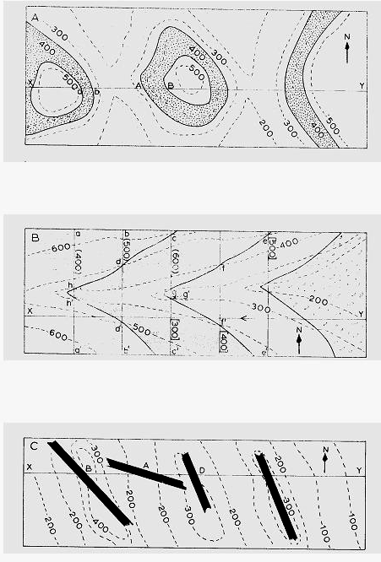

PART TWO: STRUCTURE CONTOURS
A structure contour is an imaginary line connecting points of equal elevation (a contour) on a single surface, such as the top of a formation. Structure contour maps are analogous to topographic maps; the former shows the surface of a geologic layers, the later shows the surface of the earth.
Structure contour maps are most commonly constructed from drill-hole data (Fig. 10). In this figure you see a faulted dome. Notice that unlike topographic contours, structure contours sometimes terminate abruptly. Gaps in the map indicate normal faults (due to tension) and overlaps indicate reverse faults ( due to compression).
Structure contour maps are used extensively in petroleum exploration to identify structural traps, and in hydrology to determine the subsurface configuration of aquifers.
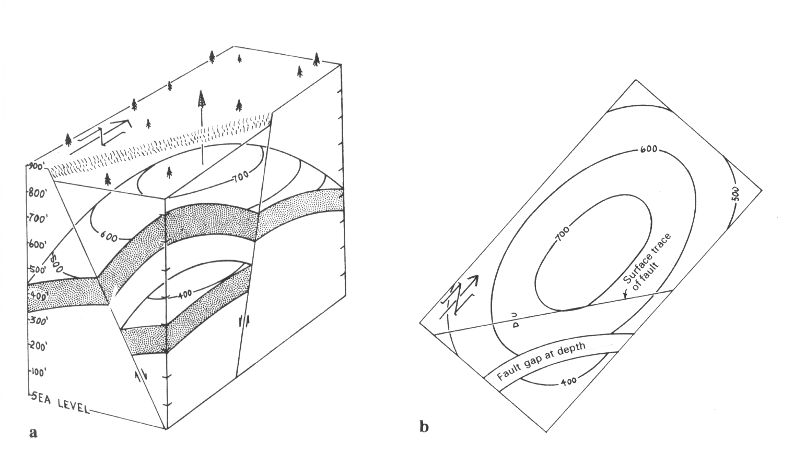

Figure (10) structure contour map of a faulted dome. Block diagram (a) and (b) map view.

Problem (2)
Figure (11) shows the elevation (in feet) of the top of Kurnub Sandstone Formation in 26 drill holes.
- Draw structure contours on Figure (11). Use a 400 m contour interval (including 0, 400, 800, 1200, etc.).
- comment on your results.
If you do not know how to begin, here are some suggestions. Find a point whose elevation is close to the elevation of a contour line, for example, the 779 m point. You know that the 800 m contour passes very close to this point, but where does it go? To the east and northeast are tow points with elevations of 516 m and 1013 m. 800 lies between these two elevations, so the 800 m contour must pass between these two points, closer to the 1013 m point than to the 516 m point. Once you have a few lines drawn, the rest will fall into place. Your structure contours should be smooth, sub-parallel lines. Use pencil, because this is a trial and error operation.

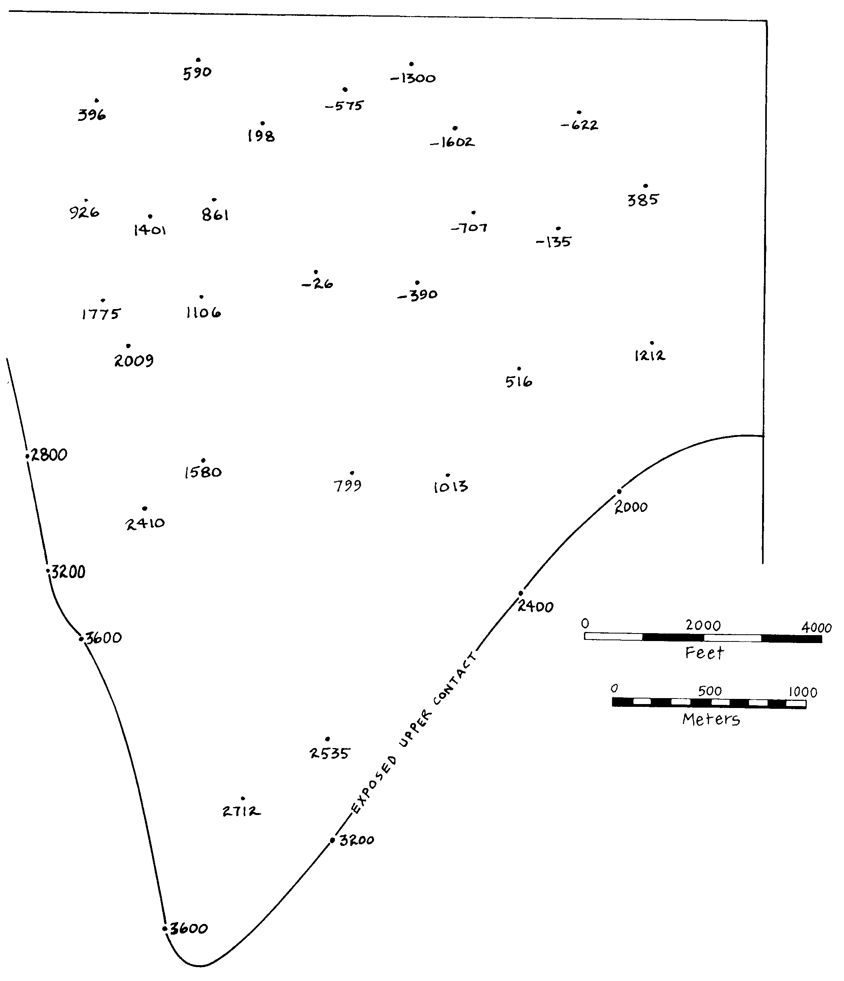

Figure (11) Map to accompany problem (2).

