THE UNIVERSITY OF JORDAN
Faculty of Science
Department of Geology

PRACTICAL STRUCTURAL GEOLOGY

LAB. (1)

Lecturer: Dr. Masdouq Al-Taj

ATTITUDES OF LINES AND PLANES

INTRODUCTION
Structural geology is the study of the features formed by geological forces. Features include; joints, faults, cleavage, folds, shear zones, foliation and lineations. Geologists can work out the order of events and see which events are related by taking simple measurements and using simple methods (but they seem complicated at first).

MEASUREMENTS AND TECHNIQUES
The most obvious thing to do when faced with a set of beds is to describe it. One way of doing this is to measure the dip and strike. The dip is the amount a bed of rock is inclined from the horizontal (ranges between 0° and 90°). The strike is the direction which is 90º from the dip direction, i.e. along the horizontal line on the inclined bed. The strike can be in two directions; hence the dip could be in one of two directions.
Some geologists, including myself, prefer to measure the dip direction, rather than strike, as it resolves this ambiguity and the strike can be calculated from the dip direction. This done by notice the direction where the strata dip as angle (by ±90° to the strike value, and here, the attitude given as dip direction first then dip angle without strike. i.e. 135°, 40°. Here dip direction is 135° (SE), hence strike is 45° and dip angle is 40°).
This is complicated slightly by apparent dip. This is due to the fact that you are not always looking edge on (perpendicular to) the bed you are measuring. If you are looking at a bed at a slight angle, then you see the apparent dip. The true dip will be greater than the apparent dip, as it is the maximum amount of dip, so the apparent dip can appear to be anything from 0° to the maximum (true) dip.
In the block diagram (A) and cross section (B) below, the dip angle is 30°, with a strike north/south (0° or 180°), the dip direction is W or 270°. On a geological map (C) below, symbols are used for the dip and strike. The strike is represented by a bar and the dip by a mark on the strike bar on the dip direction with the dip written alongside, as shown on the map below.
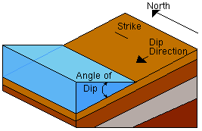
30º
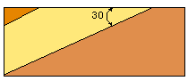
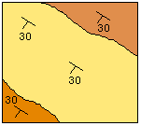

(A) Block diagram
(B) Cross section
(C) Map view
The following terms are used to describe the orientation of line and planes:
- Attitude: The orientation in space. By convention, the attitude of plane is expressed as its STRIKE, DIP ANGLE and DIP DIRECTION, the attitude of line is expressed as TREND and PLUNGE.
- Bearing: The horizontal angle between a line and specified coordinate direction, usually the true north direction.
- Strike: The bearing of a horizontal line on an inclined plane. The strike is a line of equal elevation on a plane. There are infinite numbers of strike lines, but every strike has its elevation.

- Dip angle: the vertical angle between an inclined plane and horizontal line perpendicular to its strike.

- Trend: the bearing of a line. Non-horizontal lines trend in the down-line direction
- Plunge: the vertical angle between a line and the horizontal.
- Pitch (Rake): the angle measured within an inclined plane between a horizontal line and the line in question.
N

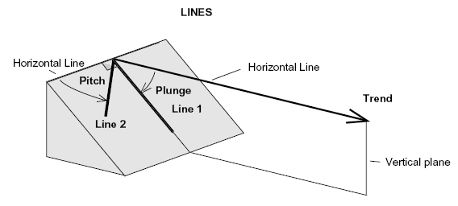
** Determine the attitude of the plane and line in the above diagrams?

HOW TO USE A COMPASS

About North
When measuring the orientation of a geological structure such as a bedding plane we normally want to compare its orientation with both north and the horizontal.

- True North: the direction of the North according to Polaris star.
- Geographic North (Grid North): North depending on Lat. And Long. On the map.
- Magnetic North: this is the direction that your compass points towards. It is not same as true north. Moreover the variation ("magnetic declination") changes over time and with your position. The first thing you need to learn, are the directions. North, South, East and West. Look at the figure and learn how they are. North is the most important.

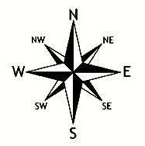

There are two main methods of expressing Attitudes of lines and planes; the “azimuth” and the “quadrant” methods:
The Azimuth Method: uses true north set to 0 (or 360) degrees. The complete circle is clockwise divided into 360 degrees. In other words, true north is 0 or 360 degrees, east is 90 degrees, south is 180º, and west is 270º. The azimuth system is the system most commonly used today.
The Quadrant Method: The quadrant system is also set with reference to both true north and true south. In this system directions (or angles) are measured in degrees, but are measured with reference to the closer of the true north or true south directions. In other words, bearing directions (angles) do not exceed 90º. For example, a bearing direction which is 30º south of due east is described as “S 60º E”.
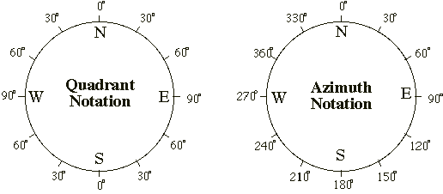

Compass needle: is always pointing towards the earth's magnetic north pole.
Compass housing: On the edge of the compass housing, you will probably have a scale. From 0 to 360º. Those are the degrees or the azimuth (or you may also call it the bearing in some contexts). And you should have the letters N, S, W and E for North, South, West and East. If you want to go in a direction between two of these, you would combine them. If you would like to go in a direction just between North and West, you simply say: "I would like to go northwest ".

HOW TO DETERMINE THE ATTITUDE OF BEDDING (by Silva compass)?
1. Determine the dip direction of the bed. The strike makes 90º with that line.
2. To measure the strike of a bed (an azimuth or bearing, relative to north); put the edge of the compass parallel to the strike. Then turn the red line in the rotated disk of the compass to fit the red needle (N direction).
3. read the angle on the circumference of the compass (take the reading less than 180º). This is the value of the strike.

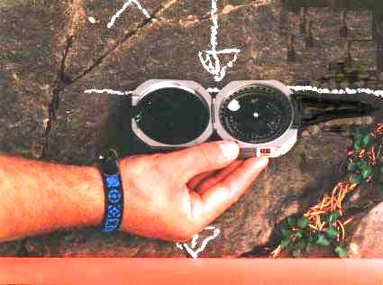

How to measure the dip angle?
- Dip angle determine using by compass using clinometer. What is a clinometer?
A clinometer is an instrument that measures the angular distance in degrees from the horizon (0°) to an object below the horizon.
- Rotate the circumference putting E-W direction along horizontal (the indicator read 0° on the protractor).
- Put the edge of the compass along the line of dip direction (perpendicular to the strike line).
- Take the value of dip where the indicator marks on the protractor. This is the value of dip angle.
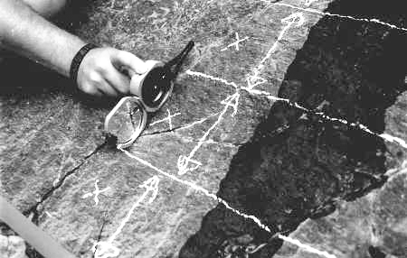

* Dip direction determine in the field by notice the direction where the strata dip (give
as direction (N, NE, SW, …. or some times as angle (±90° to the strike value, and here, the attitude given as dip direction first then dip angle with out strike. i.e. 150°, 35°. Here dip direction is 150° (SE) and dip angle is 35°)).

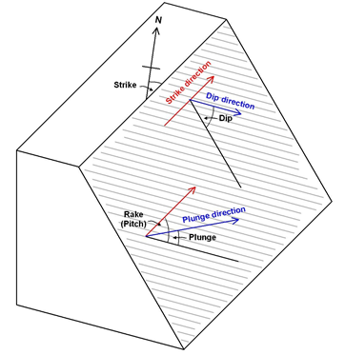

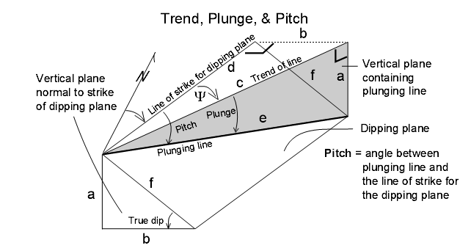

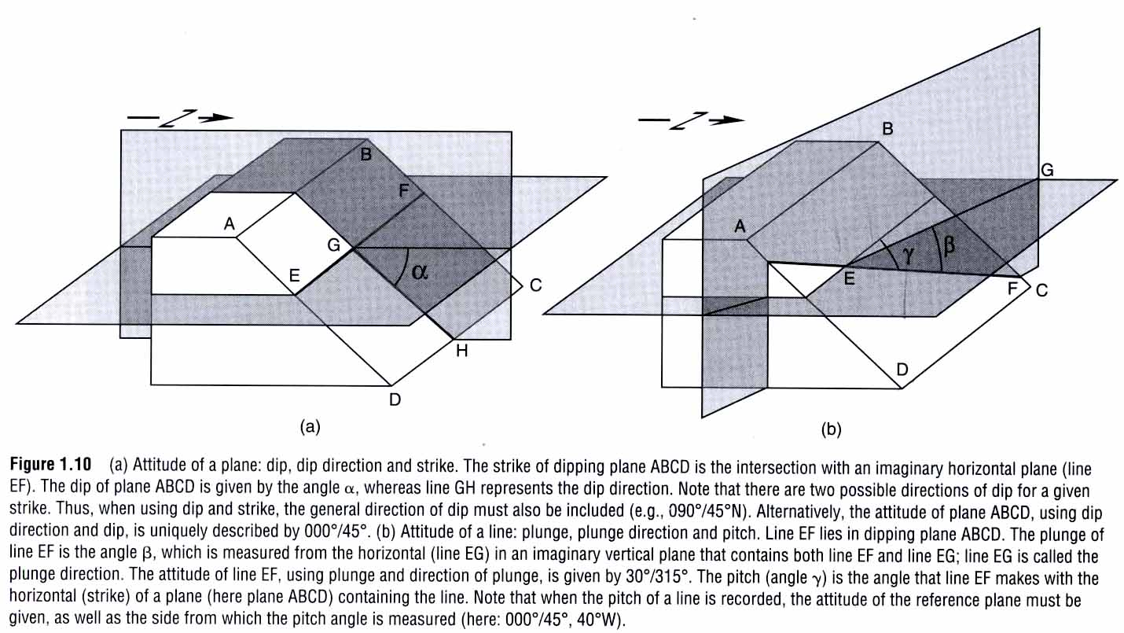

PROBLEMS
1. Translate the azimuth convention into the quadrant convention, or vice versa.

a) N12ºE= | f) N37ºW=
b) 298º= | g) 233º=
c) N86ºW= | h) 270º=
d) N55ºE = | i) 083º=
e) 126º= | j) N3ºW=

2. Circle those attitudes that are impossible (i.e., a bed with the indicated strike cannot possibly dip in the direction indicated).
a) 314º, 49ºNW |  | f) 333º, 15ºSE
b) 086º, 43ºW |  | g) 089º, 43ºN
c) N15ºW, 87ºNW |  | h) 065º, 36ºSW
d) 345º, 62ºNE |  | i) N65ºW, 54ºSE
e) 062º, 32ºS |  | j) 125º, 30º NW

3. Convert the following readings from CLAR readings to GEOLOGICAL readings.
30˚/30˚ 150˚/40˚ 210˚/70˚ 330˚/60˚

4. Fault surfaces sometimes contain overprinted slip lineations (fault striae). Such slip lineations can be used to determine the orientation of slip on a fault, and, therefore, whether the motion on the fault was strike-slip, dip-slip, or oblique-slip. A geology student who was just learning to use a Brunton compass recorded the orientations of five slip lineations on one fault surface. The strike and dip of the fault surface is 320º, 47ºNE. The student’s five recorded lineation orientations are recorded in the table below. Determine which lineation orientations are feasible and which ones must represent a mistake on the part of the student because the given orientation does not lie within the fault plane. Give a brief explanation for each of your five answers. For the valid lineation orientations, indicate which type of fault motion is indicated.

Lineation  (plunge and trend) | Feasible?  (Yes or No) | Explanation | Type of motion indicated (strike-slip, dip-slip, or  oblique-slip)
a) 34°, Due north
b) 0°, 140°
c) 33°, N66°W
d) 47°, 050°
e) 75°, Due north

Q5. Complete the measurements; write them according to the figures.

