Hashemite University
Name: ……………
ID:……………
Duration: (50min)
16/4/2015
Faculty of Engineering/ Civil Eng. Department
Statics (110401211)
2nd 2014/2015 2nd Exam
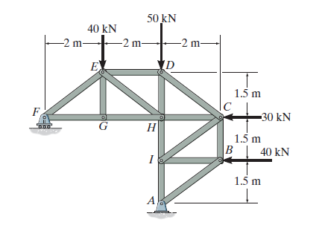
Q.1 ( 7 points) Determine the force in members DC,HC, and HI and FE of the truss, and state if the members are in tension or compression.
1. 5 m
1. 5 m
1. 5 m
20 kN
1m

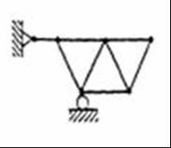
10N

b. ( 2 points) Study the stability of the truss shown
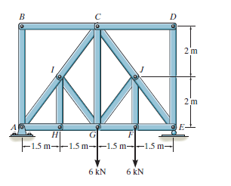
8 kN
8 kN

c. ( 2 points) Find the zero force members by inspection
( show them on the truss)
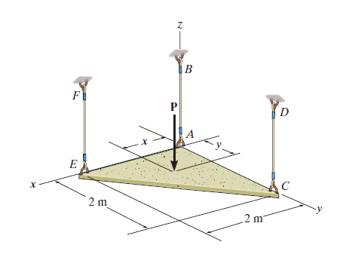
Q.2 ( 7 points) For the plate shown of weight = 10 kN located at the center of the triangular plate. and subjected to a moment of 20 kN.m as shown in the figure, supported by three members that can support tension or compression. Determine the force in each member ( EF, AB, CD )
20kN.m
10 kN

3 m
3 m

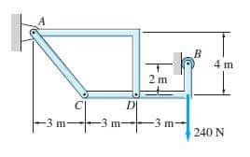
Q.3 (7 points) Determine the support reactions at A and B. and the forces which the pins C and D exert on member BDC of the frame.
Draw FBD for each element of the frame

