Hashemite University
Name: ……………
ID:……………
Duration: ( 50min)
5/11/2008
Faculty of Engineering/ Civil Eng. Department
Statics ( 0401211)
1st semester 2008/2009 Exam I

1. ( 4 points) Replace the force system acting on the beam by an equivalent force and specify its location from point A.
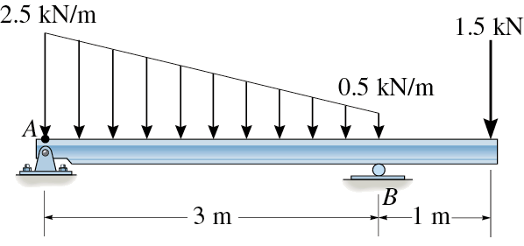

2- ( 2 points) For the coplanar force system below:
Determine the magnitude R of the resultant force and the angle θ that the resultants makes with the positive x-axis.

R = ________________
φ = ________________
3- ( 3 points) The crate is suspended by three cables as shown. The tension in cable AB is 200 N: Determine the tensions in cables AC and AD and the weight of the crate ( W) .

T_{AC} = ________________
T_{AD} = ________________
W = ________________

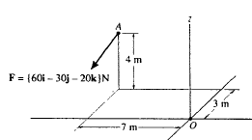

4- ( 2 points) Express the moment of the force F about point O as Cartesian vector =

……………………………………
x
y
b

( 1point) Find the Magnitude of the moment about O = …………………………..

( 2points)Determine the moment of the force about the O-b axis

5- ( 3 points) Determine the coordinate direction angles of force F₁ so that the resultant of the three forces is : F_{R} = {350 i } N
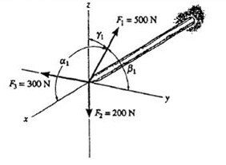

6- ( 3 points)What is the resultant couple moment acting on the beam shown. Indicate its direction.
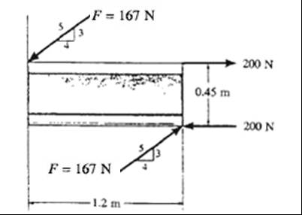

M_{R} = ………………………….

1.2 m

