 | Department of Civil Engineering  Statics First Exam  Student Name:  Student No.:  Section No.:
Question 1 (4marks): If the magnitude of the resultant force is to be 9 kN directed along the positive x – axis, determine the magnitude of the force T and its angle θ.

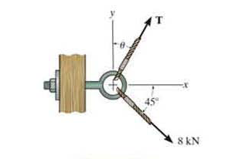
8 kN
45 °
θ
Xθ
Yθ

Question 2 (3marks): If force F to have a component along the u – axis of Fu = 6 kN, determine the magnitude of F and the magnitude of its component Fv along the v – axis. Show the components on the drawing.
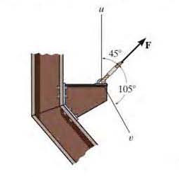
u
v
105°
45°

Question 3 (5marks): Determine the magnitude of forces F1, F2 and F3 so that the particle is held in equilibrium.
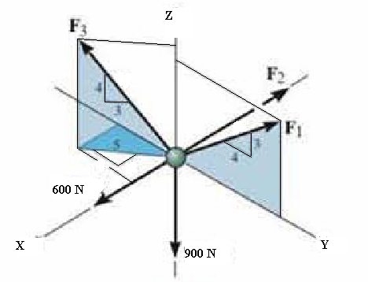
F₃

F₂₃
4
54
34
4
34
34
4
54
54
F₁₃

Question 4 (6marks): Determine the moment produced by the force F about line AF of the rectangular block below. Express the result as a Cartesian vector.
F=-6i+3j+10k N
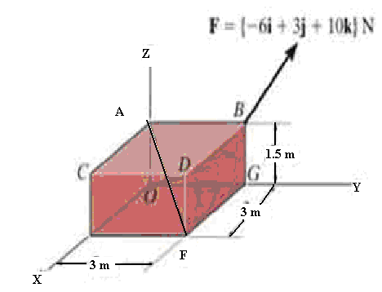

Question 5 (7marks): Replace the force and couple moment system by a resultant force and couple moment at point A. Neglect the thickness of the beam.
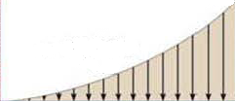
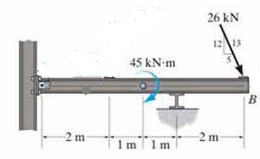
w=0.5x³ kN/m
A
26 kN
5
125
135
45kN.m

