Hashemite University | 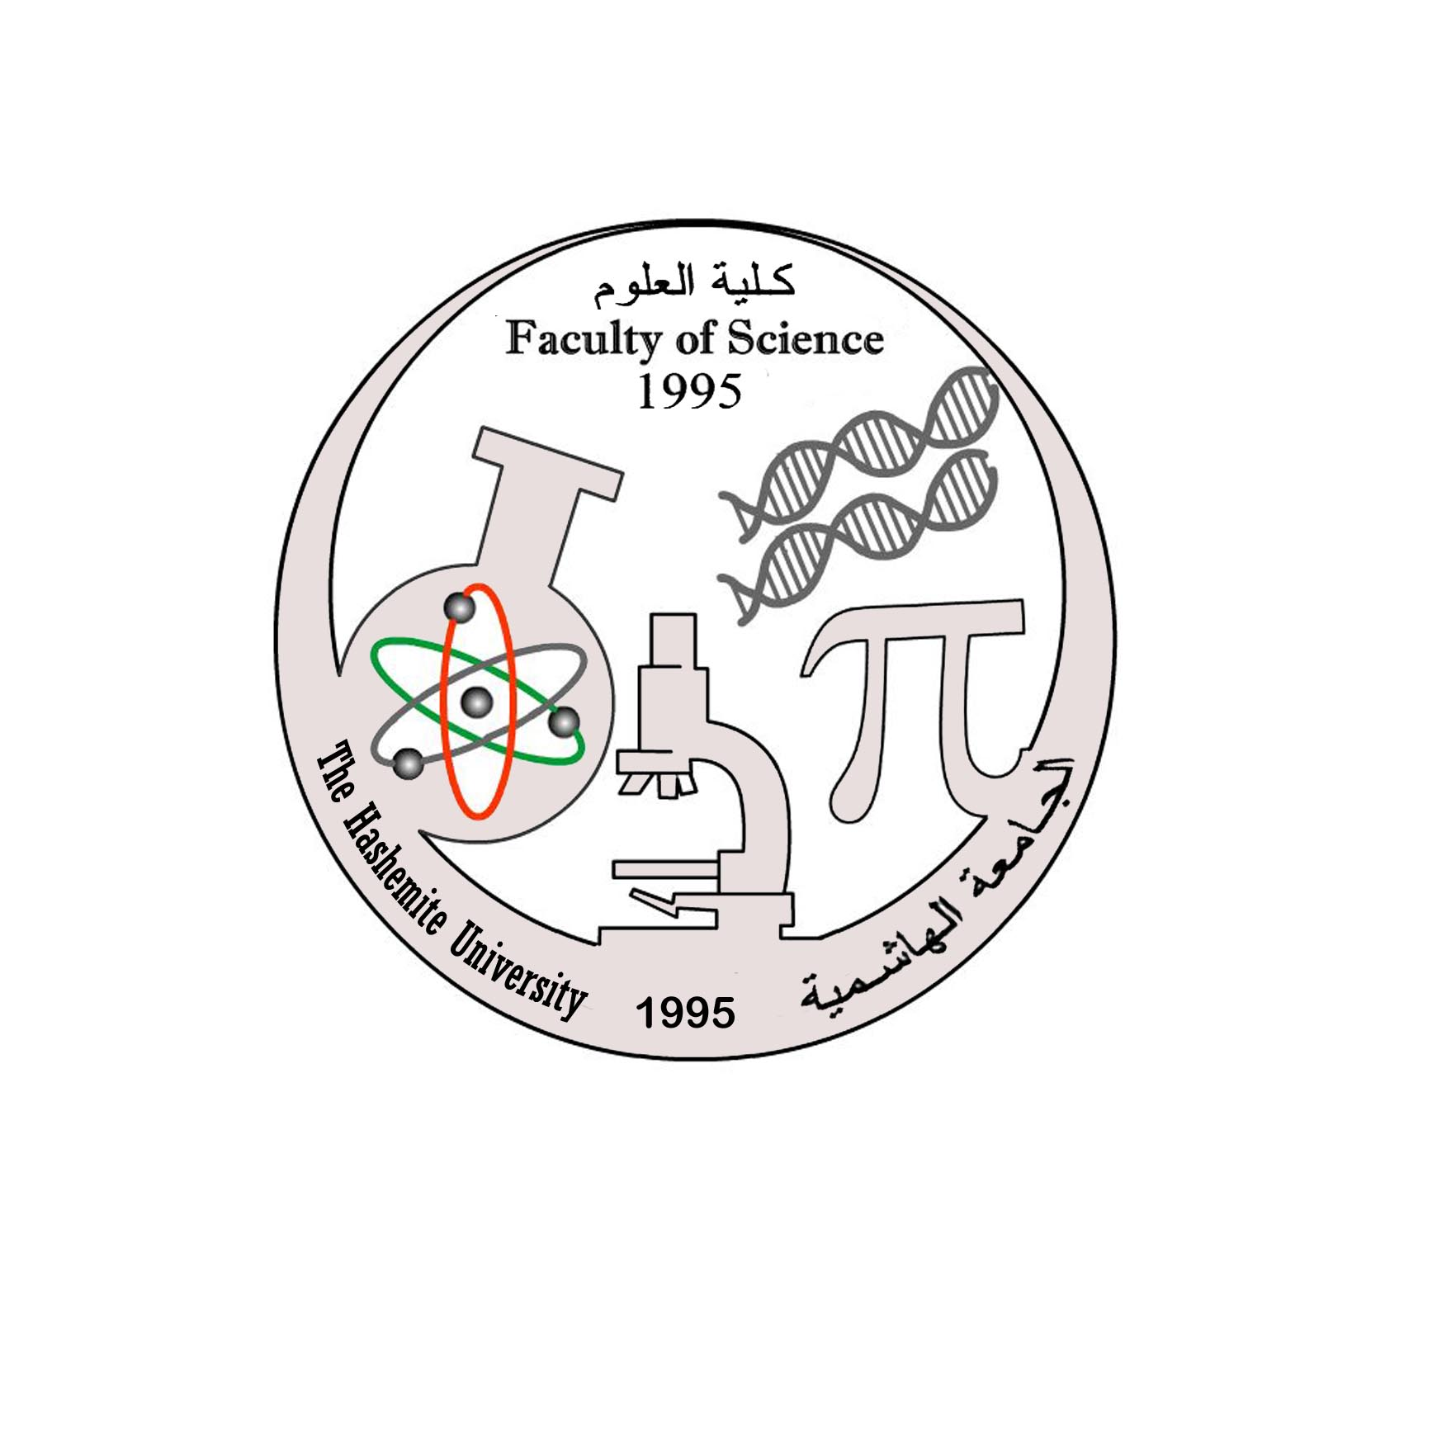  Course Syllabus | General Biology (2)  (110104102)  3 Credit Hours
Faculty of Science |  | Pre-requisite: 110108105
Department of Biology and Biotechnology |  | Second Semester 2012/2013

Course Information
 | Lecture's Time
 | Lecture Room
Rajaa Abueideh | Instructor
www.staff.hu.edu.jo/rajaa | Internet Home Page
Room No. 103 bio. Build. or at the Herbarium lab. | Office Location
 | Office Hours
Text Book : Title: Biology
Author: Sylvia S. Mader
Publisher: Mc Graw Hill.
Year :2013
Eleventh edition
* Biology  Author(s):N. A. Campbell and J. B. Reece.  Publisher: Benjamin Cummings, San Francisco.  * Any other book in General Biology | References(s)

Grading Policy:
Theory
1st Exam 25% or 20%
2nd Exam 25% 20%
Other - 10%
Final Exam 50% 50%
Course Objectives

To provide students with basic knowledge of the animal form and function.
- To understand and appreciate the unifying characteristics, diversity and complexity in animals.
- To understand the concept of homeostasis and different animal's body homeostatic mechanisms.
- To investigate the physiological activities of life.
- To gain basic information about the structure and organization of animals.
- To take basic principles of ecology; population, community and ecosystem.
- To identify ecological problems in the biosphere
Teaching and Learning Methods
1. Theory classes
2. Website www.mhhe.com / maderbiology11

Course Contents
Week | Topic | Chapter in Text
1 | Animal Organization and Homeostasis | 31
2 | Animal Organization and Homeostasis | 31
3 | Circulation and Cardiovascular systems | 32
4 | Circulation and Cardiovascular systems  Lymph Transport and Immunity | 32  33
5 | Lymph Transport and Immunity | 33
6 | Digestive Systems and Nutrition  First Exam | 34
7 | Digestive Systems and Nutrition  Respiratory Systems | 34  35
8 | Respiratory Systems  Body Fluid Regulation and Excretory Systems | 35  36
9 | Body Fluid Regulation and Excretory Systems | 36
10 | Neurons and Nervous Systems | 37
11 | Second Exam  Locomotion and Support Systems | 39
12 | Hormones and Endocrine Systems | 40
13 | Hormones and Endocrine Systems  Reproductive Systems | 40  41
14 | Reproductive Systems | 41
15 | Final Exam

Participation and Exams:
Attendance is absolutely mandatory. Students who miss 6 class sessions (15%) without a compelling excuse will be dismissed.
Exams: The TWO periodic exams and the FINAL exam will cover material presented in class as well as information from the textbook.
There will be NO make-ups for unexcused missed exams, those who miss one lecture examination that can be document and that are considered a valid excuse by the instructor, should talk to their instructor BEFORE the exam and arrangements may be scheduled.

