Hashemite University
 |   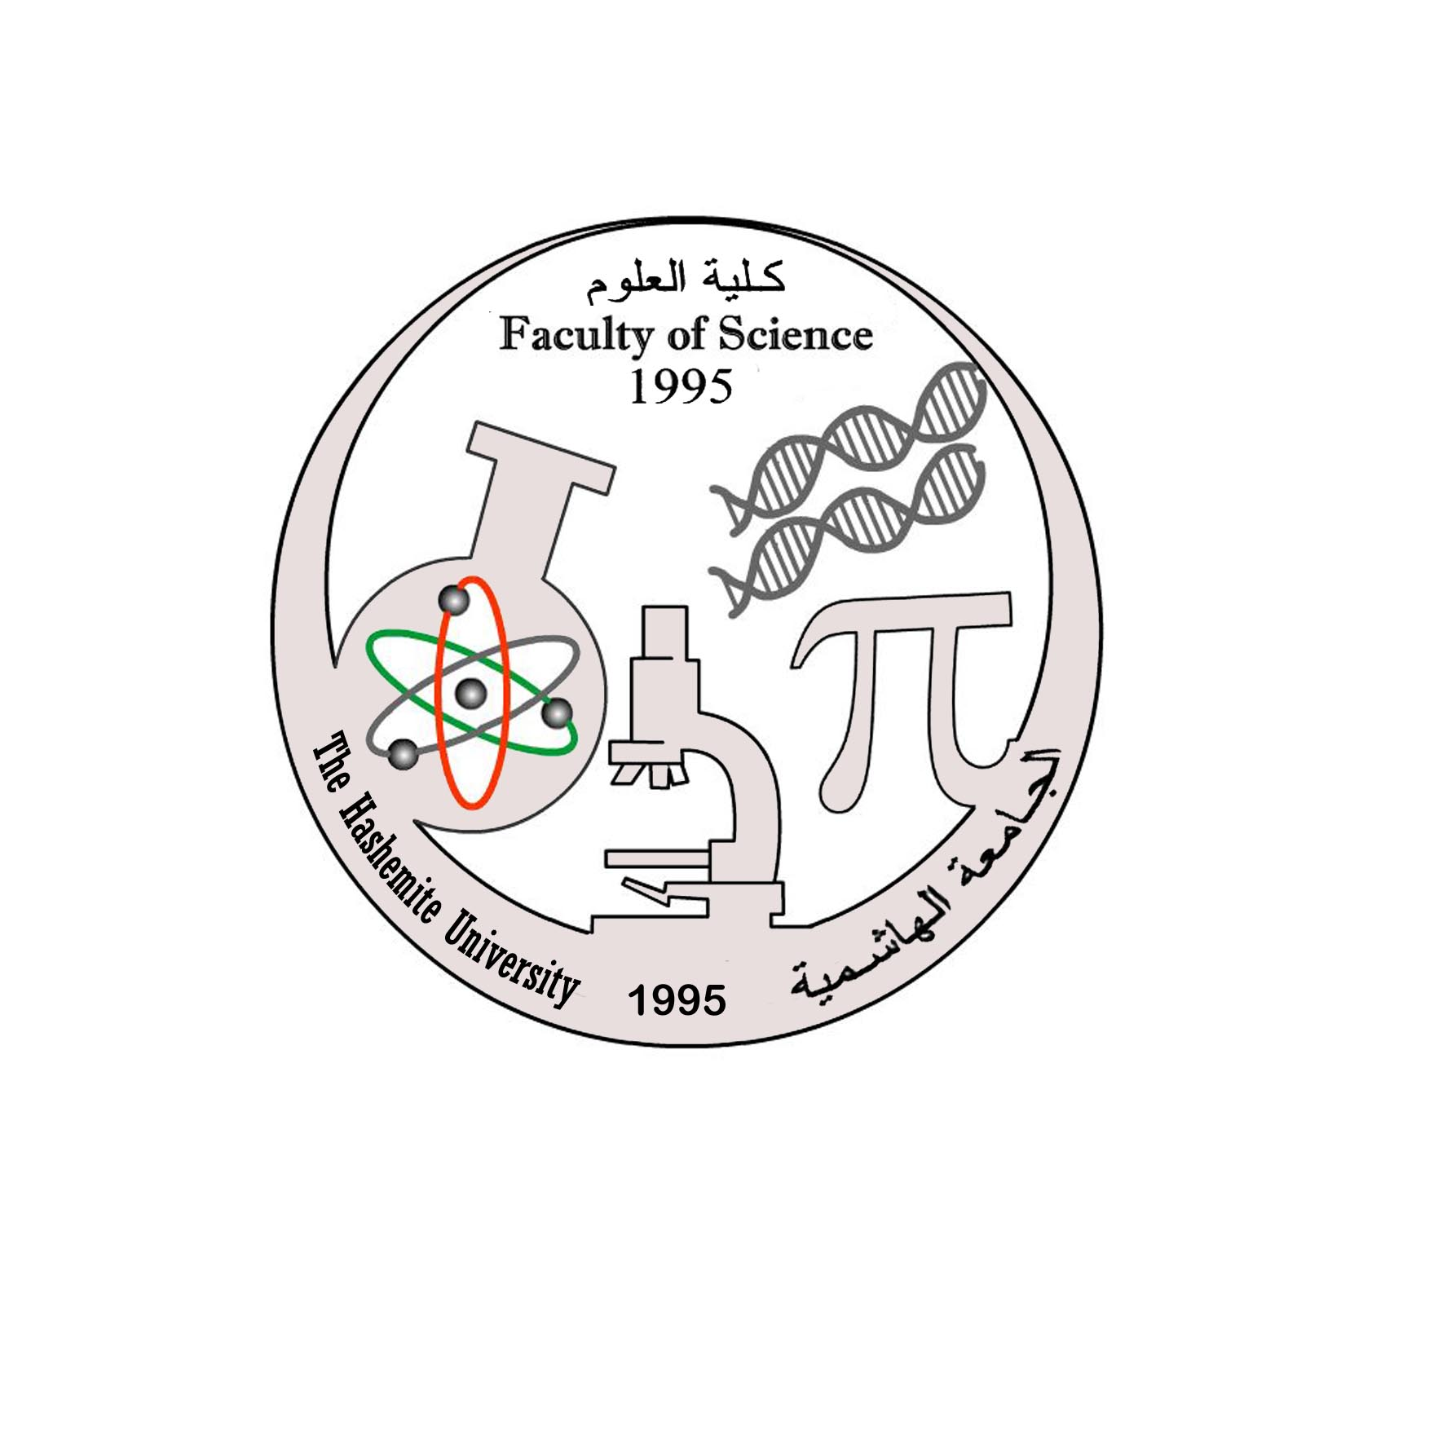  Tentative  Course Syllabus | General Biology 1  110108105  3 Credit Hours
Faculty of Science |  | Prerequisite(s):
Department of Biology & Biotechnology |  | First Semester  2016/2017

Course Information
Lecture’s Time
Lecture’s Room
Instructor | Rajaa Abueideh
Internet Home Page | www.staff.hu.edu.jo/rajaa
Office Location | 103 at Biology building or at herbarium

Office Hours
Text Book | Title: Biology  Author(s):N. A. Campbell, J. B. Reece and others.  Publisher: Benjamin Cummings, San Francisco.  Year :2013  Tenth edition
References | Other textbooks in Biology
Grading Policy
Assessment Type |  | Expected Date | Weight
First Exam |  | 6th week | 30
Second Exam |  | 11th week | 30
Final Exam |  | 15th week | 40
Course Objectives
- To present the students with an overview of biology to be able to analyze the basic concepts behind the major themes of biology.
- To understand the current state of knowledge of a number of areas in biology including chemistry of organic molecules, cell biology, energy transfer and genetics.
Teaching and Learning Methods
1- Theory classes.
2-Website www.campbellbiology.com ( use your access code listed in your textbook)

Course Contents
Week | Topic | Chapter in Text
1 | Carbon: The Basis of Molecular Diversity of Life | 4
2 | Carbon: The Basis of Molecular Diversity of Life  Biological Macromolecules and Lipids | 4  5
3 | Biological Macromolecules and Lipids | 5
4 | Cell Structure and Function | 7
5 | Cell Structure and Function  Membrane Structure and Function | 7  8
6 | Membrane Structure and Function  First Exam | 8
7 | Energy and Life | 6
8 | Energy and Life  Cellular Respiration | 6  10
9 | Cellular Respiration | 10
10 | Photosynthesis | 11
11 | Mitosis  Second Exam | 12
12 | Sexual Life Cycles and Meiosis | 13
13 | Nucleic Acids and Inheritance | 16
14 | Nucleic Acids and Inheritance  Expression of Genes | 16  17
15 | Final Exam

Participation and Exams:
Attendance is absolutely obligatory. Students who miss 6 class sessions (15%) without a compelling excuse will be dismissed.
Exams: The TWO periodic exams and the FINAL exam will cover material presented in class as well as information from the textbook.
There will be NO make-ups for unexcused missed exams, those who miss one lecture examination that can be document and that are considered a valid excuse by the instructor, should talk to their instructor BEFORE the exam and arrangements may be scheduled.

