Chapter 1: basic Radiation Physics

Atomic Structure

The atom is a basic unit of matter consisting of a dense, central nucleus surrounded by a cloud of electrons. The atomic nucleus contains a mix of protons and neutrons

Electrons are tiny, very light particles that have a negative electrical charge (-).

Protons are much larger and heavier than electrons and have a positive charge (+).

Neutrons are large and heavy like protons without any charge

Modern Models of Hydrogen Atom

Bohr Model:
The electrons rotate around the nucleus in "orbits" as planets orbit the sun. Each orbit represents an energy level of those electrons.

Quantum model:
The electron cannot be found precisely, but we can predict the probability of an electron being at some location in the atom

The binding energy between the electron and the atom is represented by the following equation:
$E_{n}=−\frac{\text{13}\text{.}6}{n^{2}}$

n = principal quantum number, no unit

Example
How much energy does one electron with a principal quantum number of n= 2 have?

Sol.:

$E_{n}=−\frac{\text{13}\text{.}6}{n^{2}}\text{ev}$$E_{n}=−\frac{\text{13}\text{.}6}{2^{2}}$$\begin{aligned} \\ E_{n}=−3\text{.}4\text{ev}\end{aligned}$

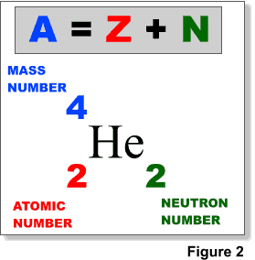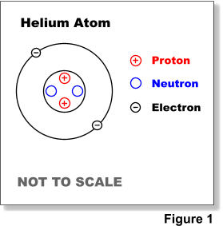

Atoms of the same element can have different numbers of neutrons. The various forms are called isotopes of that element. As an example hydrogen has three (3) isotopes:

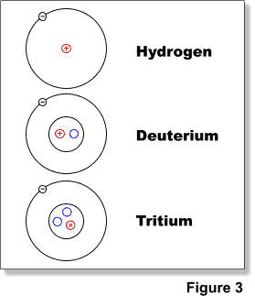

Radiation

- Radiation is the flow of energy through space electromagnetic waves such as visible light, ultraviolet and gamma ray

- Ionizing radiation is radiation that produces ions in matter. It is able to disrupt chemical bonds of molecules and cause biologically important changes

Type of ionizing radiation:
Electromagnetic waves:
- X- Rays:
Electromagnetic waves emitted by an electrical device with wavelength in the range of 10 to 0.01 nanometers
- Gamma Rays: Electromagnetic waves produced by unstable or radioactive isotopes. wavelength less than 10 picometers
Particles:
- Neutrons
- Electrons, beta rays
- Protons
- Alphas: nuclei of helium atoms, composed of two protons and two neutrons. They are positively charged, and are usually emitted when heavy radioactive isotopes, such as uranium, break down.
- Heavy Ions: nuclei of any atoms that have been stripped of their electrons. They move at great speeds and have large amounts of energy

- Non-ionizing radiation: type of electromagnetic radiation that does not carry enough energy to ionize atoms to completely remove an electron from an atom or molecule l

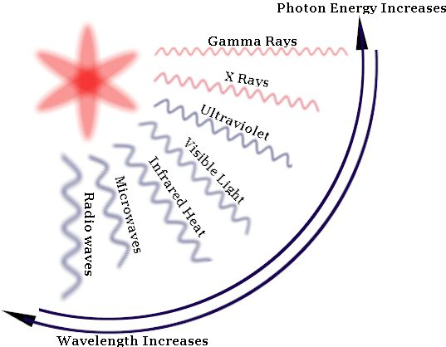

Radiation units

- Activity is the transformation (disintegration) rate of a radioactive substance

- Curie (Ci)

- Becquerel (Bq) - S.I. Unit
- 1 Bq = 1 disintegration per second (dps)
- 1 Ci = 3.7 x 10-¹⁰ dps

Exposure: is the charge release per unit mass of air

S.I. Unit : C/kg
Roentgen (R)= 2.58/10000 C/kg

Absorbed dose is the energy imparted by radiation onto an absorbing material.
S.I. Unit
Gray (Gy) - SI Unit 1 Gy = 1 joule per kilogram
1 Gy = 100 rads

Dose Equivalent (DE) regarding to biological effect.
DE = Absorbed Dose x Quality Factor (Q)
Q depends on the type of radiation.
Q = 1 for gamma, x-ray and beta
Q = 10 for alpha
S.I. Unit
- SIEVERT (Sv) -
1 Sv = 100 rems

- Nominal background radiation absorbed dose of 100 mrad/year = 1 mGy/yr.

- Nominal background radiation dose biological equivalent of 100 mrem/year = 1mSv/yr.

- Occupational whole body limit is 5 rem/yr = 50 mSv/yr

- Kerma: The kinetic energy of all the charged particles liberated by uncharged ionizing radiation ((indirectly ionizing radiation [photons and neutrons] )) in a unit mass of material

$K=\frac{\text{Energy}}{\text{Mass}}$

S.I. Unit: joule per kilogram = Gy (Gray)

- Flux (Φ)
Flux is the number of photons or particles per second per unit area.

- SI unit: Particle/ m².s

Mass–energy equivalence:
a measured quantity of energy is equivalent to a measured quantity of mass which could be expressed by the relation
$$E={\text{MC}}^{2}=\frac{M_{0}}{\sqrt{1−\frac{v^{2}}{C^{2}}}}$$
where E is energy, m is mass, mo is rest mass, v is speed of the particles and c is the speed of light in a vacuum, which is 300,000 km per second.

Energy for rest mass particle
$$E=M_{0}C^{2}$$

$\begin{aligned}E_{e}=0\text{.}\text{511}\text{Mev} \\ E_{p}≃E_{n}=\text{931}\text{.}5\text{Mev}=1u\end{aligned}$ $\begin{aligned}M_{e}=9\text{.}1×{\text{10}}^{\text{.}\text{31}}\text{kg} \\ M_{p}≃M_{n}=1\text{.}\text{66}×{\text{10}}^{−\text{27}}\text{kg}\end{aligned}$
u: atomic mass unit

